Liber*M Refactor – Conversion Tools User Guide
Release 1.0
mLogica
August 2026
Revision: RP
Copyrights
Copyright © mLogica, LLC 2026. All rights reserved.
mLogica has intellectual property rights relating to technology that is described in this document.
This document and the product to which it pertains are distributed under licenses restricting their use, copying, distribution, and decomplication. No part of the product or of this document may be reproduced in any form by any means without prior written authorization of mLogica and its licensors, if any.
IBM, CICS, DB2, IMS, MQSeries, MVS, OS/390, RACF, System z, VTAM, WebSphere, z/OS, and zSeries are trademarks or registered trademarks of International Business Machines Corporation in the United States, other countries, or both.
Micro Focus, the Micro Focus logo, and Micro Focus product names are trademarks or registered trademarks of Micro Focus IP Development Limited or its subsidiaries or affiliated companies in the United States, United Kingdom, and other countries.
Microsoft, Windows, PowerShell, and the Windows logo are trademarks of Microsoft Corporation in the United States, other countries, or both.
Oracle and Java are registered trademarks of Oracle and/or its affiliates. All other marks are the property of their respective owners.
DOCUMENTATION IS PROVIDED "AS IS" AND ALL EXPRESS OR IMPLIED CONDITIONS, REPRESENTATIONS AND WARRANTIES, INCLUDING ANY IMPLIED WARRANTY OF MERCHANTABILITY, FITNESS FOR A PARTICULAR PURPOSE OR NON-INFRINGEMENT, ARE DISCLAIMED, EXCEPT TO THE EXTENT THAT SUCH DISCLAIMERS ARE HELD TO BE LEGALLY INVALID.

Preface
This document is intended for end users, application analysts, and modernization team members who use the Liber*M Refactor tool to convert legacy mainframe artifacts — COBOL, JCL, and PROCLIB/PROC members, and BMS/CICS/MFS screen definitions — into modern target languages such as C#, Java, Groovy, PowerShell, TypeScript, HTML, and JSON.
It assumes a working knowledge of the source mainframe environment (COBOL, JCL, PROCLIB) and a basic familiarity with the corresponding target technology for the conversion being performed.

How This Guide Is Organized
- Chapter 1, Introduction, describes the Liber*M Refactor tool and the conversions it supports.
- Chapter 2, Getting Started, describes prerequisites, the common package structure, and the general conversion workflow shared by every conversion type.
- Chapter 3, COBOL to C# Conversion, describes converting COBOL Batch and COBOL Online programs to C#.
- Chapter 4, JCL to Groovy Conversion, describes converting JCL to Groovy using the Clerity conversion engine.
- Chapter 5, JCL to PowerShell Conversion, describes converting JCL to PowerShell scripts.
- Chapter 6, PROCLIB to PowerShell Conversion, describes converting PROC members to PowerShell scripts.
- Chapter 7, PROCLIB to Groovy Conversion, describes converting PROC members to Groovy.
- Chapter 8, BMS/CICS/MFS to JSON/HTML/TypeScript Conversion, describes converting BMS map sets to JSON, HTML, and TypeScript, and CICS COBOL online programs to Java.
- Chapter 9, COBOL to Java Conversion, describes converting COBOL to Java, building and deploying the converted application, and validating both online and batch processing.
- Chapter 10, Common Troubleshooting, describes tools and techniques — conversion logs, and the Analyze.bat utility — that apply across all conversion types.
- Appendix A, Configuration Quick Reference, summarizes the configuration file, pattern, source, and output location for every supported conversion.

Contents
Preface 3
How This Guide Is Organized 3
Introduction 7
Clerity Conversion Engine 7
Conversion Flow 7
Conversions Covered in This Guide 7
Getting Started 9
Prerequisites 9
Software Requirements 9
Hardware Requirements 9
Obtaining and Preparing the Conversion Package 9
Common Package Structure 9
General Conversion Workflow 11
COBOL to C# Conversion 12
Overview 12
Common Preparation 12
Option 1: Converting COBOL Batch Programs to C# 13
Step 1: Verify the Configuration File 13
Step 2: Enable the Batch Configuration 13
Step 3: Run the Conversion 13
Batch-Specific Configuration Reference 13
Option 2: Converting COBOL Online Programs to C# 14
Step 1: Verify the Configuration File 14
Step 2: Enable the Online Configuration 14
Step 3: Run the Conversion 14
Online-Specific Configuration Reference 14
Output Validation 15
JCL to Groovy Conversion 17
Overview 17
Conversion Procedure 17
Step 1: Extract the Project Files 17
Step 2: Select the Conversion Type 17
Step 3: Verify the Conversion Configuration 17
Step 4: Enable the Required Conversion 17
Step 5: Execute the Conversion 17
Examples 17
Verifying the Generated Output 20
JCL to PowerShell Conversion 23
What This Conversion Does 23
Prerequisites 23
Folder Structure Overview 23
Running the Conversion 23
Step 1: Open the Package 23
Step 2: Verify the Source Files 23
Step 3: Verify the Conversion Files 23
Step 3a: Configure Convert.bat 23
Step 3b: Verify the XML Configuration 23
Step 4: Start the Conversion 23
Step 5: Wait for Completion 23
Step 6: Verify the Generated Target Folder 23
Step 7: Verify the Generated PowerShell Files 23
Step 8: Review the Generated Code 23
Expected Conversion Output 27
Validation Checklist 28
Important Notes 29
Quick Start Summary 29
PROCLIB to PowerShell Conversion 30
Overview 30
Conversion Procedure 31
Step 1: Extract the Package 31
Step 2: Verify the Source Files 31
Step 3: Verify the Configuration File 31
Step 4: Enable the Configuration 31
Step 5: Run the Conversion 31
Configuration Reference 32
Output Validation 33
PROCLIB to Groovy Conversion 34
Overview 34
Conversion Procedure 35
Step 1: Extract the Package 35
Step 2: Verify the Source Files 35
Step 3: Verify the Configuration File 35
Step 4: Enable the Configuration 35
Step 5: Run the Conversion 35
Configuration Reference 36
Output Validation 37
BMS/CICS/MFS to JSON/HTML/TypeScript Conversion 38
What This Conversion Does 38
Prerequisites 38
Folder Structure Overview 38
Converting BMS Map Sets to JSON/HTML/TypeScript 38
Step 1: Open the Source Folder 38
Step 2: Verify the Source Files 38
Step 3: Configure the Conversion 38
Step 4: Run the Conversion 38
Step 5: Wait for Completion 38
Step 6: Verify the Generated Output 38
Step 7: Review the Generated Code 38
Converting CICS COBOL Online Programs to Java 43
COBOL to Java Conversion 46
What This Chapter Covers 46
Prerequisites 46
Running the COBOL to Java Conversion 46
Importing and Building the Converted Project 47
Importing the Project into IntelliJ 47
Building with Maven 47
Resolving the Angular Build Failure (Missing Node.js) 47
Starting Application Services with Docker 50
Starting Docker Compose Services 50
Verifying Services in Docker Desktop 50
Testing Online Transactions 51
Method 1: TN3270 Emulator 51
Method 2: Angular UI (Browser) 51
Testing Batch Jobs (boot-batch) 60
Submitting a Job via Postman 60
Checking Job Status 60
Job List 60
Verifying via Docker Logs 60
Testing with Node Class B 60
Submitting via Swagger UI 60
Local Debugging Setup 65
Transaction-to-Program Mapping (pct.json) 65
Troubleshooting 68
Common Troubleshooting 70
Identifying the Issue 70
Resolution Steps 70
Reviewing Conversion Logs 70
Using Analyze.bat 70
Resolving Common Analyze.bat Issues 70
Executable Name Mismatch 70
General Troubleshooting Checklist 71
Configuration Quick Reference 72

CHAPTER 1

Introduction
Liber*M Refactor is a modernisation platform that helps organizations transform legacy mainframe applications, databases, and workloads into modern, cloud-ready solutions. It combines automated discovery, code conversion, data migration, testing, and governance capabilities to accelerate modernization while preserving critical business logic.
Liber*M Refactor supports source technologies such as COBOL, Assembler, PL/I, and Natural, together with the surrounding job-control and screen-definition artifacts (JCL, PROCLIB/PROC members, and BMS/CICS/MFS map sets) that make up a mainframe application. This guide focuses on six of the conversion paths available through the tool.

Clerity Conversion Engine
Clerity is the code conversion engine within the Liber*M Refactor platform. It automates the transformation of legacy mainframe assets into modern target-language applications, and supports a wide range of mainframe components, including COBOL, Assembler (ASM), Copybooks (CPY), Batch Programs, Online Programs, ASM Macros, Catalogued Procedures (CATLG), CSD Definitions, JCL, PROCs, and BMS map sets.
By leveraging rule-based transformation, Clerity accelerates the conversion process while preserving existing business logic and application behaviour, reducing manual effort and improving conversion accuracy.

Conversion Flow
Every conversion performed by Liber*M Refactor follows the same high-level flow:
- Source Code Analysis – the source artifacts (COBOL, JCL, PROC, or BMS) are identified and parsed.
- Automated Conversion – the Clerity engine applies the conversion rules defined in the selected configuration.
- Validation & Review – conversion logs and reports are checked for errors or unsupported constructs.
- Target Code Generation – the converted source files are written to the output project.
- Deployment Readiness – the generated code is reviewed, and where applicable, built and tested in the target environment.

Conversions Covered in This Guide
Source | Target | See
COBOL (Batch and Online) | C# | Chapter 3
JCL | Groovy | Chapter 4
JCL | PowerShell | Chapter 5
PROCLIB / PROC members | PowerShell | Chapter 6
PROCLIB / PROC members | Groovy | Chapter 7
BMS / CICS / MFS map sets | JSON, HTML, TypeScript | Chapter 8
CICS COBOL Online programs | Java (via BMS conversion) | Chapter 8
COBOL (Batch and Online) | Java | Chapter 9

Each conversion type uses the same underlying engine and package structure (see Chapter 2), but is driven by its own XML configuration file and, in most cases, its own conversion command.

CHAPTER 2

Getting Started
This chapter describes what you need before you can run a conversion, the folder structure shared by every conversion package, and the general workflow that applies to all six conversion types. The chapters that follow build on this common workflow and describe only what is specific to each conversion.

Prerequisites

Software Requirements
- Operating System: Windows 10/11 or equivalent
- Java JDK: JDK 8 or above
- For Java Use: IntelliJ IDEA (or another supported IDE such as Eclipse): installed and configured, used to view, build, and validate the converted application code
- For C# Use: Microsoft Visual Studio
- The Liber*M Refactor conversion package for the application to be converted (for example, aws_cards_demo_v1.8.4)
- A valid Liber*M/NIB license key
- Command Prompt (CMD): available on the system
- Microsoft Excel: recommended, for reviewing the Analyze.bat error reports
- aws_cards_demo_v1.8.4.zip (Source Folder)

Hardware Requirements
- Processor: Intel Core i5 (or equivalent/higher processor).
- RAM: minimum 8 GB
- Storage: minimum 20 GB of free disk space
- Internet connection: required for downloading dependencies and updates

Obtaining and Preparing the Conversion Package
The conversion package (for example, aws_cards_demo_v1.8.4.zip) should be obtained from your project's approved distribution location. Extract the package completely to a local working directory before starting any conversion, and verify that the folders and files described below are present.
- Place the package archive in the directory where you want to install it — for example, D:\aws_cards_demo_v1.8.4.
- Extract the archive. On Windows, right-click the archive and choose Extract All, or use your preferred zip utility.
- Verify that the extracted folder contains the batch files, configuration files, the conversion engine executable, a sources folder, and a logs folder.

Common Package Structure
Every Liber*M Refactor conversion package is organized around a source folder and a target (output) folder. The names vary slightly between packages, but the structure and purpose of each item is consistent:
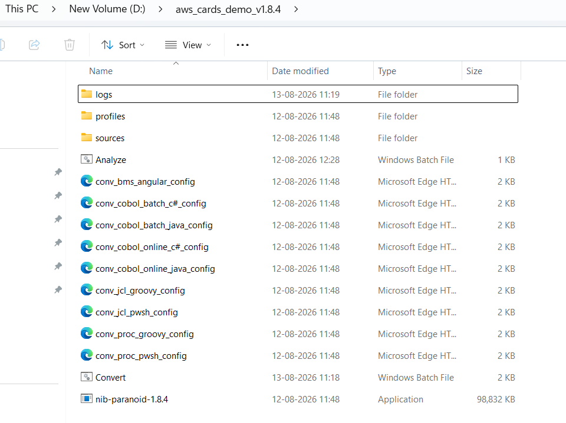

Figure 1: Contents of the source package folder (aws_cards_demo_v1.8.4), showing the conversion engine, configuration files, and supporting folders.
Item | Purpose
sources | Contains the input legacy source files (COBOL, JCL, PROC, or BMS) to be converted.
profiles | Contains generated conversion profile and skeleton files used internally by the engine.
logs | Stores the log files generated during each conversion run.
conv_*_config.xml | One configuration file per conversion type, defining the file pattern, source location, and output location.
Convert.bat / ConvertNew.bat | Batch script that starts the conversion. Each package includes one or the other (or both).
Analyze.bat | Helper script that reads the conversion logs and produces an Excel error report.
nib-paranoid-<version>.exe | The Liber*M/NIB conversion engine executable that performs the actual code transformation.

The converted output is written to a separate target project — for example, nib-java-demo-apps-csharp or nib-java-demo-apps — which is generated automatically by the conversion process and does not need to be created manually.
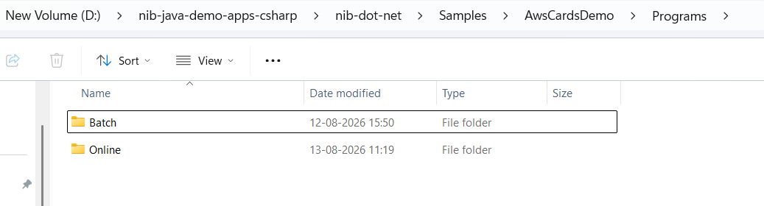

Figure 2: Example output project structure: converted programs are organized into Batch and Online folders under the target project.

General Conversion Workflow
Every conversion in this guide follows the same five steps. The chapters for each conversion type describe the specific configuration file, command, and output location to use at each step.
- Verify the input files. Confirm that the legacy source files to be converted are present in the sources folder of the package.
- Verify the configuration file. Open the XML configuration file for the conversion you want to run and confirm the <resources> element: the pattern attribute selects which files are processed, location is the source folder, and output is the destination for the generated code.
- Enable the conversion command. Open Convert.bat (or ConvertNew.bat) in a text editor and make sure only the command line for the required conversion is uncommented (that is, not preceded by ::).
- Run the conversion. Execute Convert.bat or ConvertNew.bat and wait for it to finish. Do not close the Command Prompt window while the conversion is running.
- Verify the output. Confirm that the converted files were generated in the expected output folder, and check the logs folder for any errors.
Note: Only enable the configuration command you intend to run in Convert.bat / ConvertNew.bat. Leaving unrelated conversion commands uncommented can cause unexpected files to be processed.

The source and output paths used by the conversion are ultimately controlled by two workspace variables set inside the batch script: DG_CONV_WORKSPACE_IN (source) and DG_CONV_WORKSPACE_OUT (target). You do not normally need to change these directly — they are derived from the package location — but they are useful to know when troubleshooting an unexpected output location.
Once the converted code has been generated, open the target project in IntelliJ IDEA (or your preferred IDE) to review, build, and test it before moving on to the next conversion.

Note : If we store JCL, CBL, BMS, CPY, etc. in a single parent folder, it will be easier to manage and maintain the project. Within that folder, we can organize the files into separate subfolders based on their type, for example, sources/cbl, sources/jcl, sources/bms, sources/cpy, and so on.
The sources folder name is just an example from the aws-card-demo project. We can use any name that best fits our requirements. The main objective is to keep all source files organized by type, making them easier to manage, locate, and use.

CHAPTER 3

COBOL to C# Conversion
This chapter describes how to convert COBOL Batch and COBOL Online programs into C# using the Liber*M Refactor conversion utility (Convert.bat). The two options use different configuration files, file-name patterns, and output locations, and are described separately below.

Overview
The conversion is initiated from the source package folder (for example, aws_cards_demo_v1.8.4), while the generated C# code is written to the output project (for example, nib-java-demo-apps-csharp). Before starting, confirm that the package has been extracted successfully and that the folders and files described in Chapter 2, Common Package Structure, are present.
Item | Description
Convert.bat | Starts the COBOL to C# conversion process.
conv_cobol_batch_c#_config.xml | Configuration file for COBOL Batch to C# conversion.
conv_cobol_online_c#_config.xml | Configuration file for COBOL Online to C# conversion.
logs | Stores log files generated during the conversion.
nib-paranoid-1.8.4.exe | Main conversion engine that performs the code conversion.

The generated programs are written to a target folder that depends on the conversion type:
Conversion | Output Folder
COBOL Batch | nib-java-demo-apps-csharp\nib-dot-net\Samples\AwsCardsDemo\Programs\Batch
COBOL Online | nib-java-demo-apps-csharp\nib-dot-net\Samples\AwsCardsDemo\Programs\Online

Common Preparation
- Extract aws_cards_demo_v1.8.4.zip if you have not already done so.
- Confirm that all COBOL source files to be converted are present in sources\cbl. These are the COBOL programs that will be converted.

Option 1: Converting COBOL Batch Programs to C#

Step 1: Verify the Configuration File
Open conv_cobol_batch_c#_config.xml and verify the source location and output path (the ${delivery_project_root} variable).

Figure 3: The <resources> element of conv_cobol_batch_c#_config.xml, showing the pattern, location, and output attributes for COBOL Batch conversion.

Step 2: Enable the Batch Configuration
Open Convert.bat and ensure the COBOL Batch configuration line (conv_cobol_batch_c#_config.xml) is enabled — that is, not commented out with double colon (::):
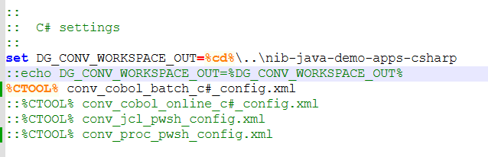

Figure 4: Convert.bat with the COBOL Batch to C# configuration line enabled.

Step 3: Run the Conversion
Run Convert.bat. The batch file initializes the workspace, validates the license, and invokes the Liber*M conversion engine.
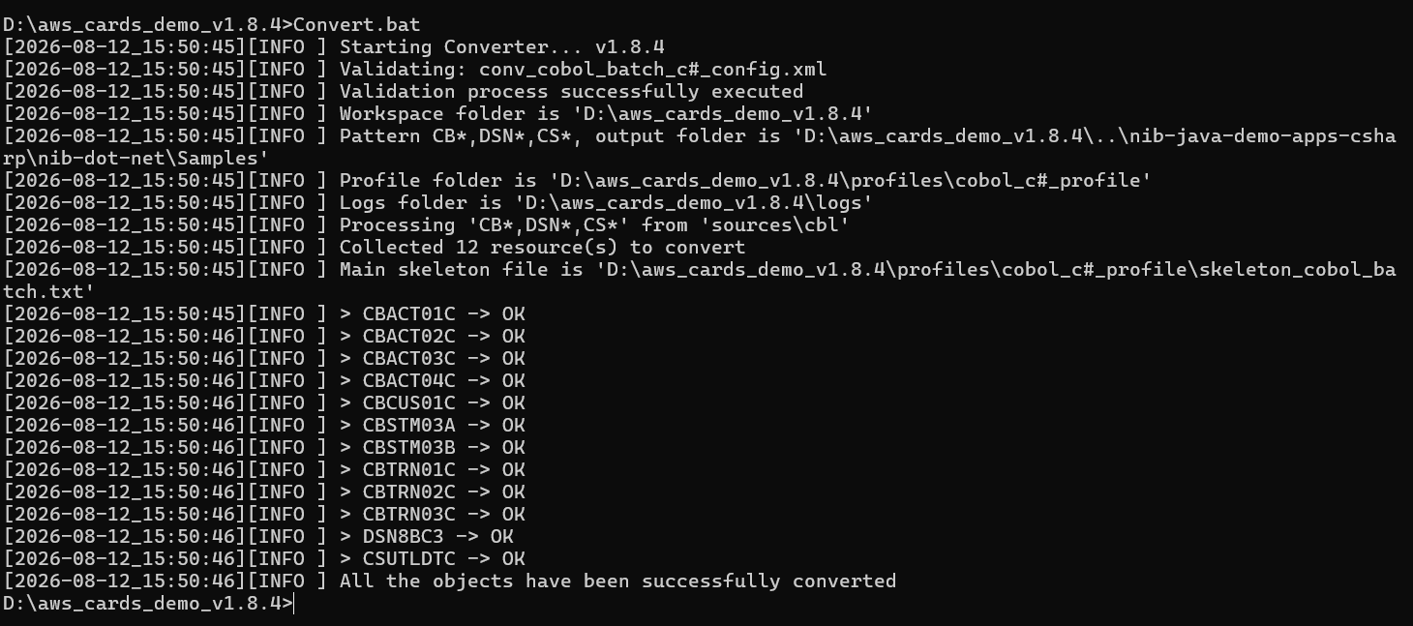

Figure 5: Convert.bat running the COBOL Batch to C# conversion, showing workspace initialization and successful completion in the Command Prompt window.
Monitor the logs folder for execution status, then verify that the converted C# programs have been generated under nib-java-demo-apps-csharp\nib-dot-net\Samples\AwsCardsDemo\Programs\Batch.

Batch-Specific Configuration Reference
Attribute | Value
Configuration file | conv_cobol_batch_c#_config.xml
Pattern | CB*, DSN*, CS*
Location | sources\cbl
Output | ${delivery_project_root}

Option 2: Converting COBOL Online Programs to C#

Step 1: Verify the Configuration File
Open conv_cobol_online_c#_config.xml and verify the source location and output path (${delivery_project_root}).

Figure 6: The <resources> element of conv_cobol_online_c#_config.xml for COBOL Online conversion.

Step 2: Enable the Online Configuration
Open Convert.bat and ensure the COBOL Online configuration line (conv_cobol_online_c#_config.xml) is enabled.
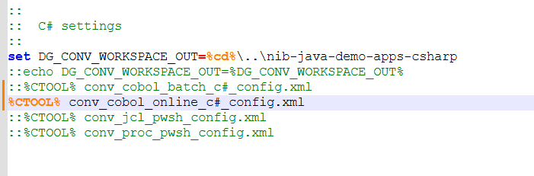

Figure 7: Convert.bat with the COBOL Online to C# configuration line enabled.

Step 3: Run the Conversion
Run Convert.bat. As with the Batch option, the script initializes the workspace, validates the license, and invokes the Liber*M conversion engine. Monitor the logs folder for execution status.
Verify that the converted C# programs are generated under nib-java-demo-apps-csharp\nib-dot-net\Samples\AwsCardsDemo\Programs\Online.
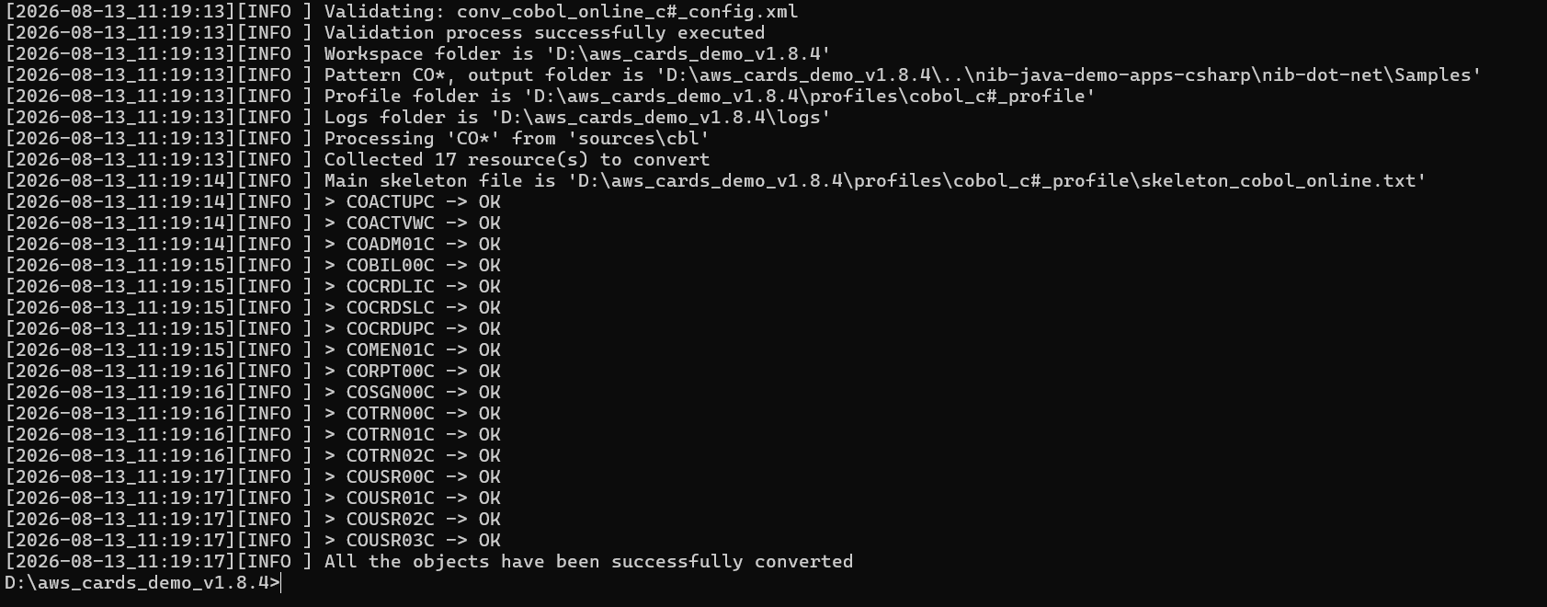

Figure 8: Successful COBOL Online to C# conversion output in the Command Prompt window.

Online-Specific Configuration Reference
Attribute | Value
Configuration file | conv_cobol_online_c#_config.xml
Pattern | CO*
Location | sources\cbl
Output | ${delivery_project_root}

Note: Use only the configuration file that corresponds to the option you are running. Enabling both Batch and Online configuration lines at the same time in Convert.bat is not recommended.

Output Validation
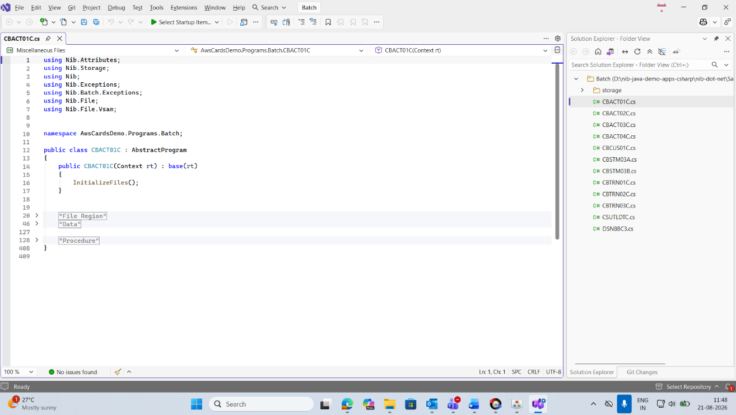

Batch Program

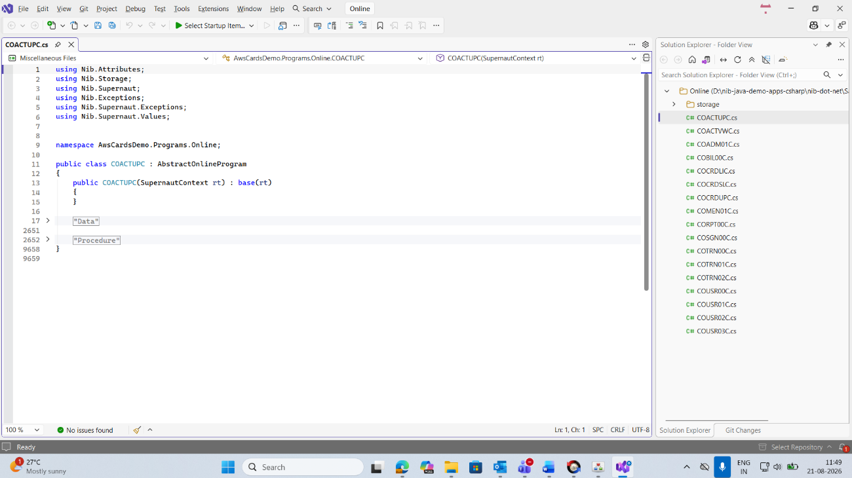

Online Program
- C# source files should be generated in the appropriate Batch or Online output folder.
- No critical errors should appear in the logs folder.
- Compare the generated C# logic with the original COBOL program to validate that the conversion preserved the expected behaviour.
For guidance that applies to all conversion types — including how to use Analyze.bat to generate a detailed error report — see Chapter 10, Common Troubleshooting.

CHAPTER 4

JCL to Groovy Conversion
This chapter describes how to convert JCL source files into Groovy using the Liber*M Refactor Clerity conversion engine.

Overview
Before starting, ensure you have access to the Liber*M_Refactor package. This folder contains the source and target applications required for the conversion.
Folder | Role
aws_cards_demo (source application) | Contains the sample mainframe application to be converted, including the JCL programs to convert.
nib-java-demo-apps (target application) | Contains the generated and compiled modernized code, including project-specific configuration files and other build resources.

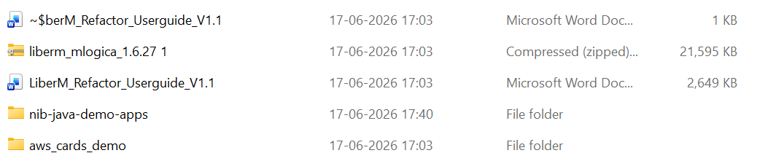

Figure 9: The Liber*M_Refactor package folder, showing the aws_cards_demo source folder and the nib-java-demo-apps target folder.

Conversion Procedure

Step 1: Extract the Project Files
Extract the Liber*M_Refactor package to your local machine and verify that the folder structure matches the layout described in Chapter 2.

Step 2: Select the Conversion Type
Liber*M Refactor supports multiple conversion types, including JCL to Groovy or PowerShell, PROCLIB to Groovy or PowerShell, COBOL to Java, COBOL to C#, CICS/BMS to JSON/TS,HTML/ Angular JS and others. For this chapter, the conversion type is JCL to Groovy. Navigate to the source folder that contains the JCL programs to be converted.

Step 3: Verify the Conversion Configuration
Open the conv_jcl_groovy_config.xml file located in the aws_cards_demo folder and verify that the source and destination paths are configured correctly.
Attribute | Description
pattern | Specifies which files are processed. pattern="*" converts all files in the source directory; a specific value such as pattern="_INICATG" converts only that file — useful for testing a single program before converting the full set.
location | The source folder containing the JCL files.
output | The destination folder where the generated Groovy files will be created.

Step 4: Enable the Required Conversion
Open the ConvertNew.bat file located in the aws_cards_demo folder and enable the conversion line for JCL to Groovy.
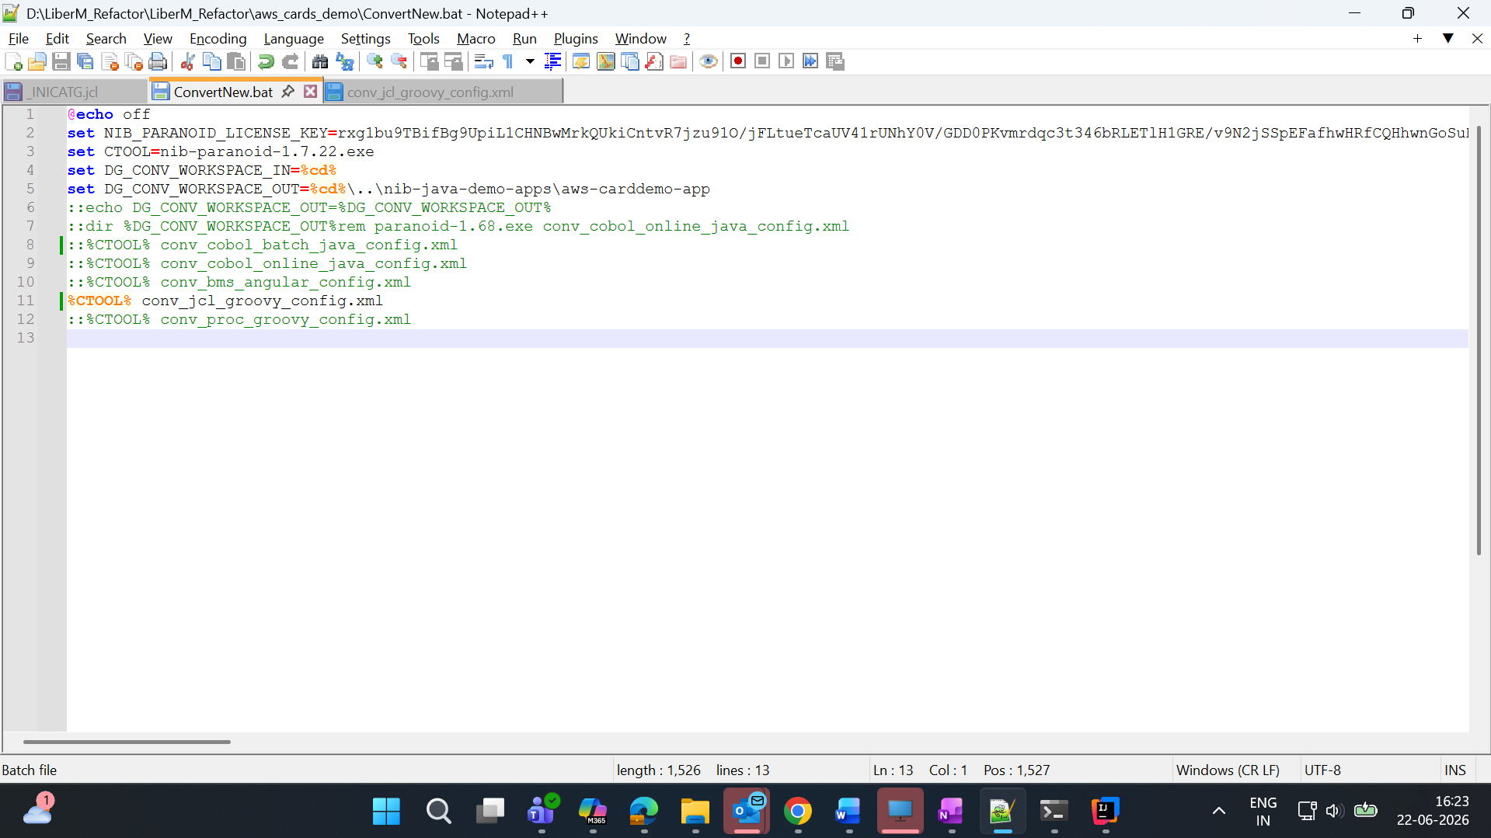

Figure 10: ConvertNew.bat and the conv_jcl_groovy_config.xml configuration file, with the JCL to Groovy conversion line enabled.

Step 5: Execute the Conversion
Open Command Prompt, navigate to the aws_cards_demo directory, and run ConvertNew.bat. The Clerity engine processes the JCL files and generates the corresponding Groovy files in the configured destination folder.

Examples
Converting all JCL files (pattern="*"):
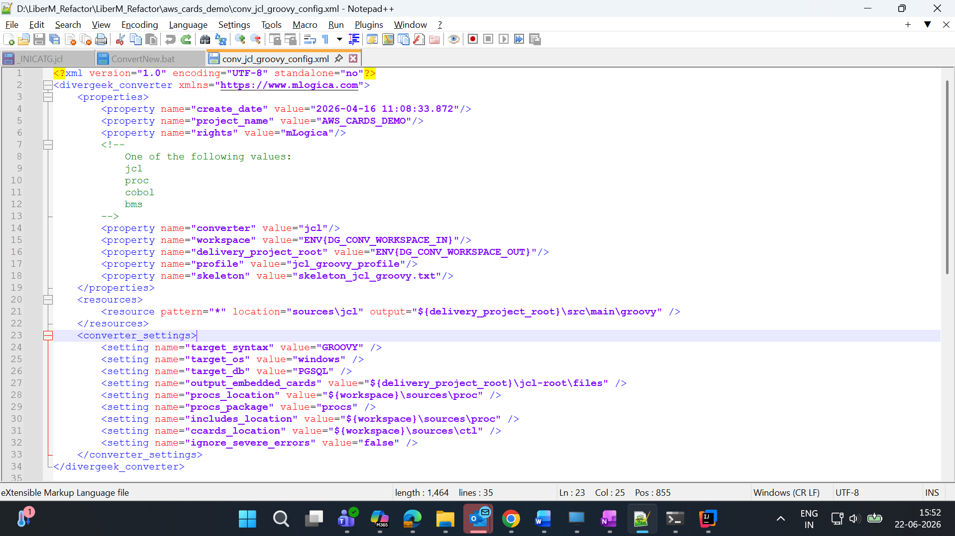

Figure 11: conv_jcl_groovy_config.xml configured with pattern="*" to convert all JCL files.
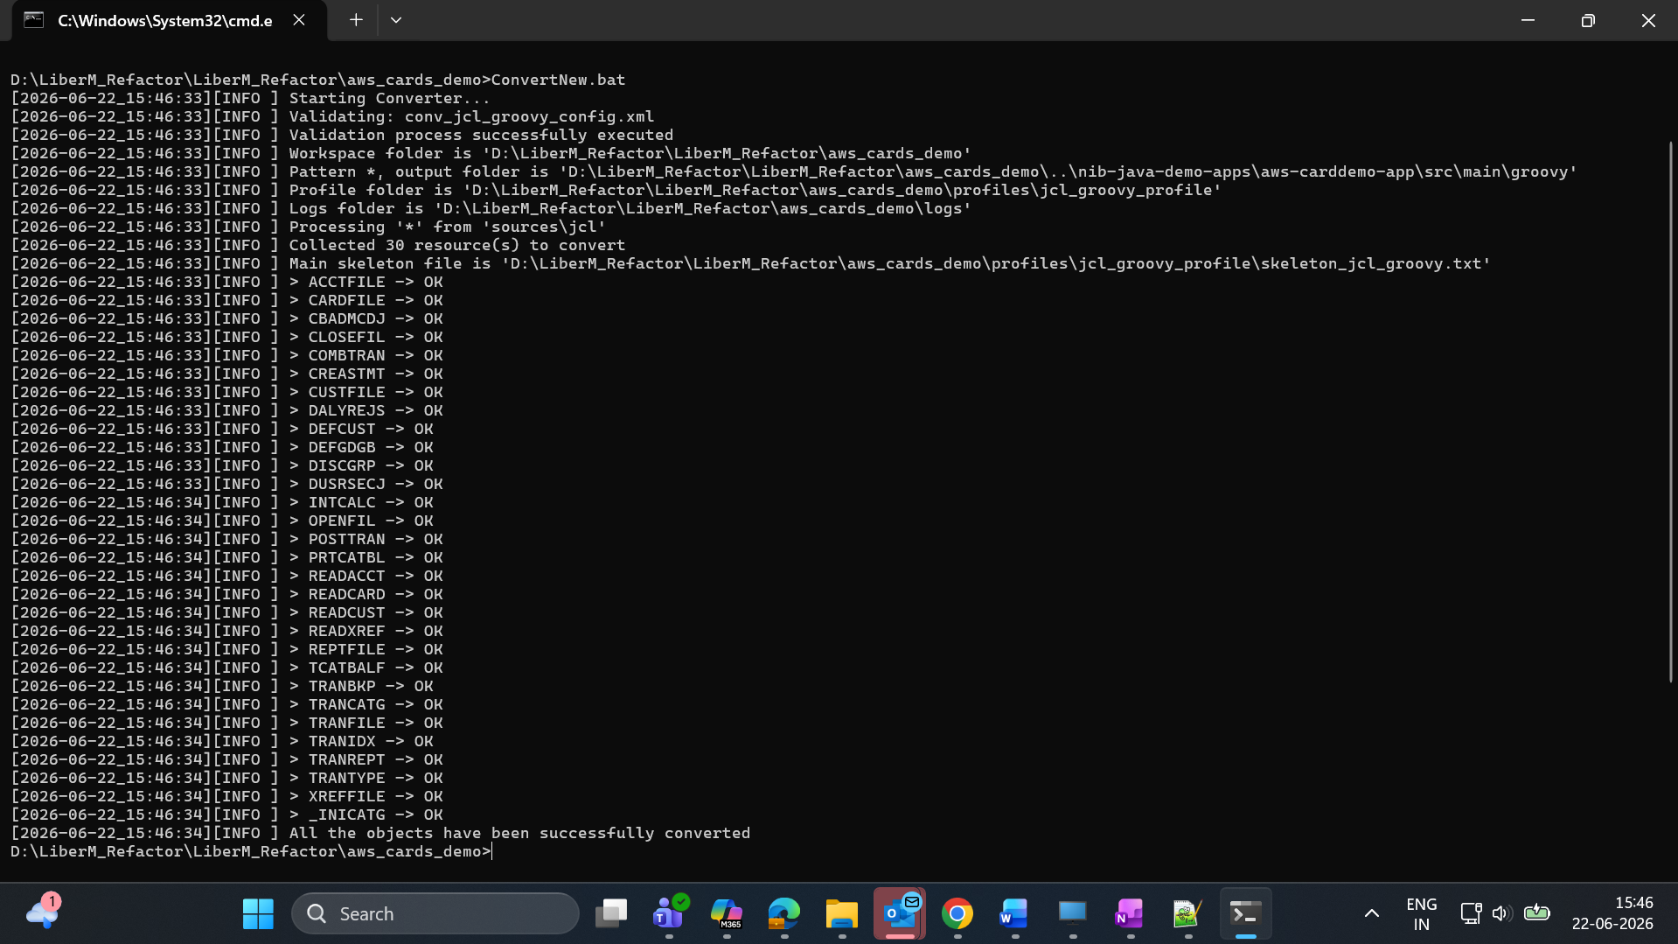

Figure 12: ConvertNew.bat running the JCL to Groovy conversion for all JCL files, with a successful completion message.
Converting a specific JCL file (for example, pattern="_INICATG"):
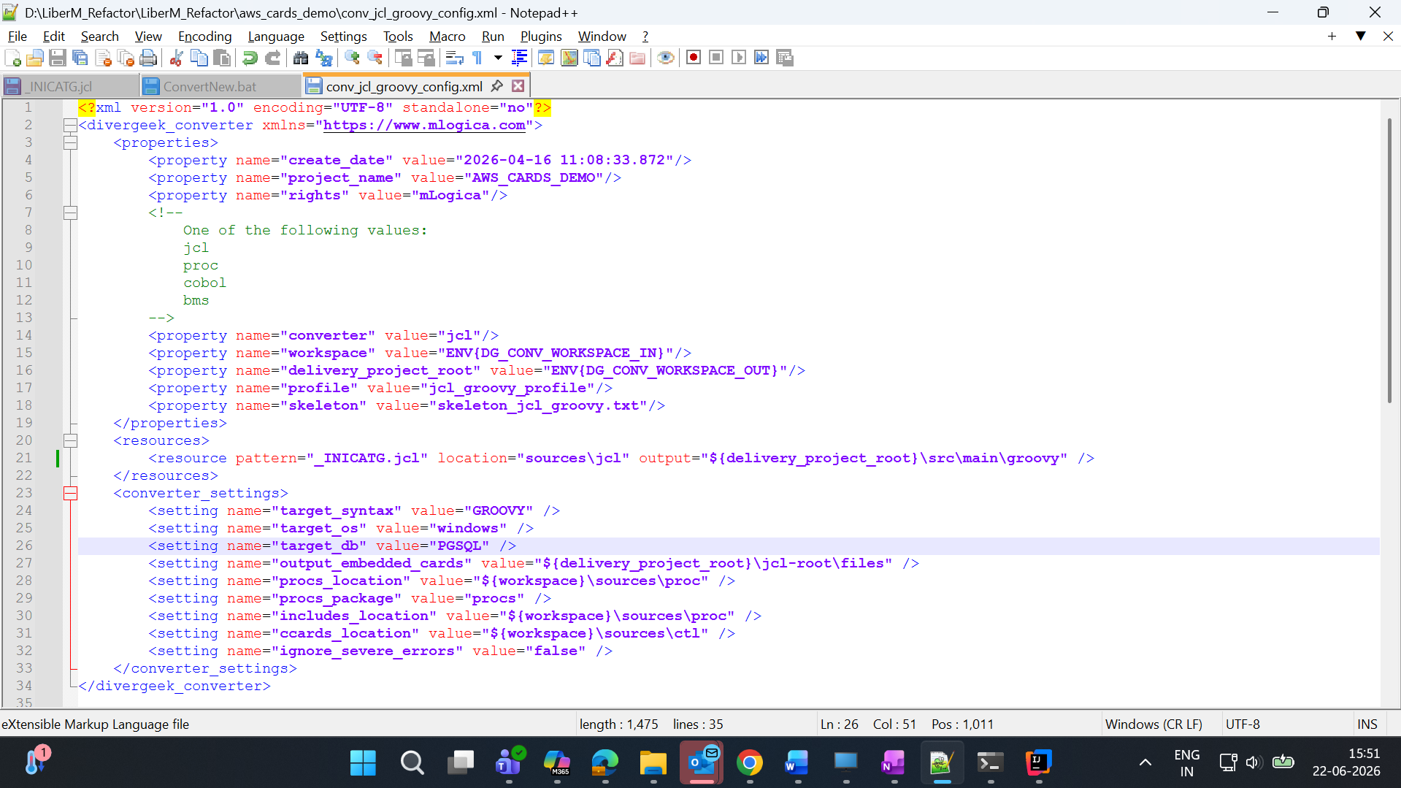

Figure 13: conv_jcl_groovy_config.xml configured to convert a single, specific JCL file.
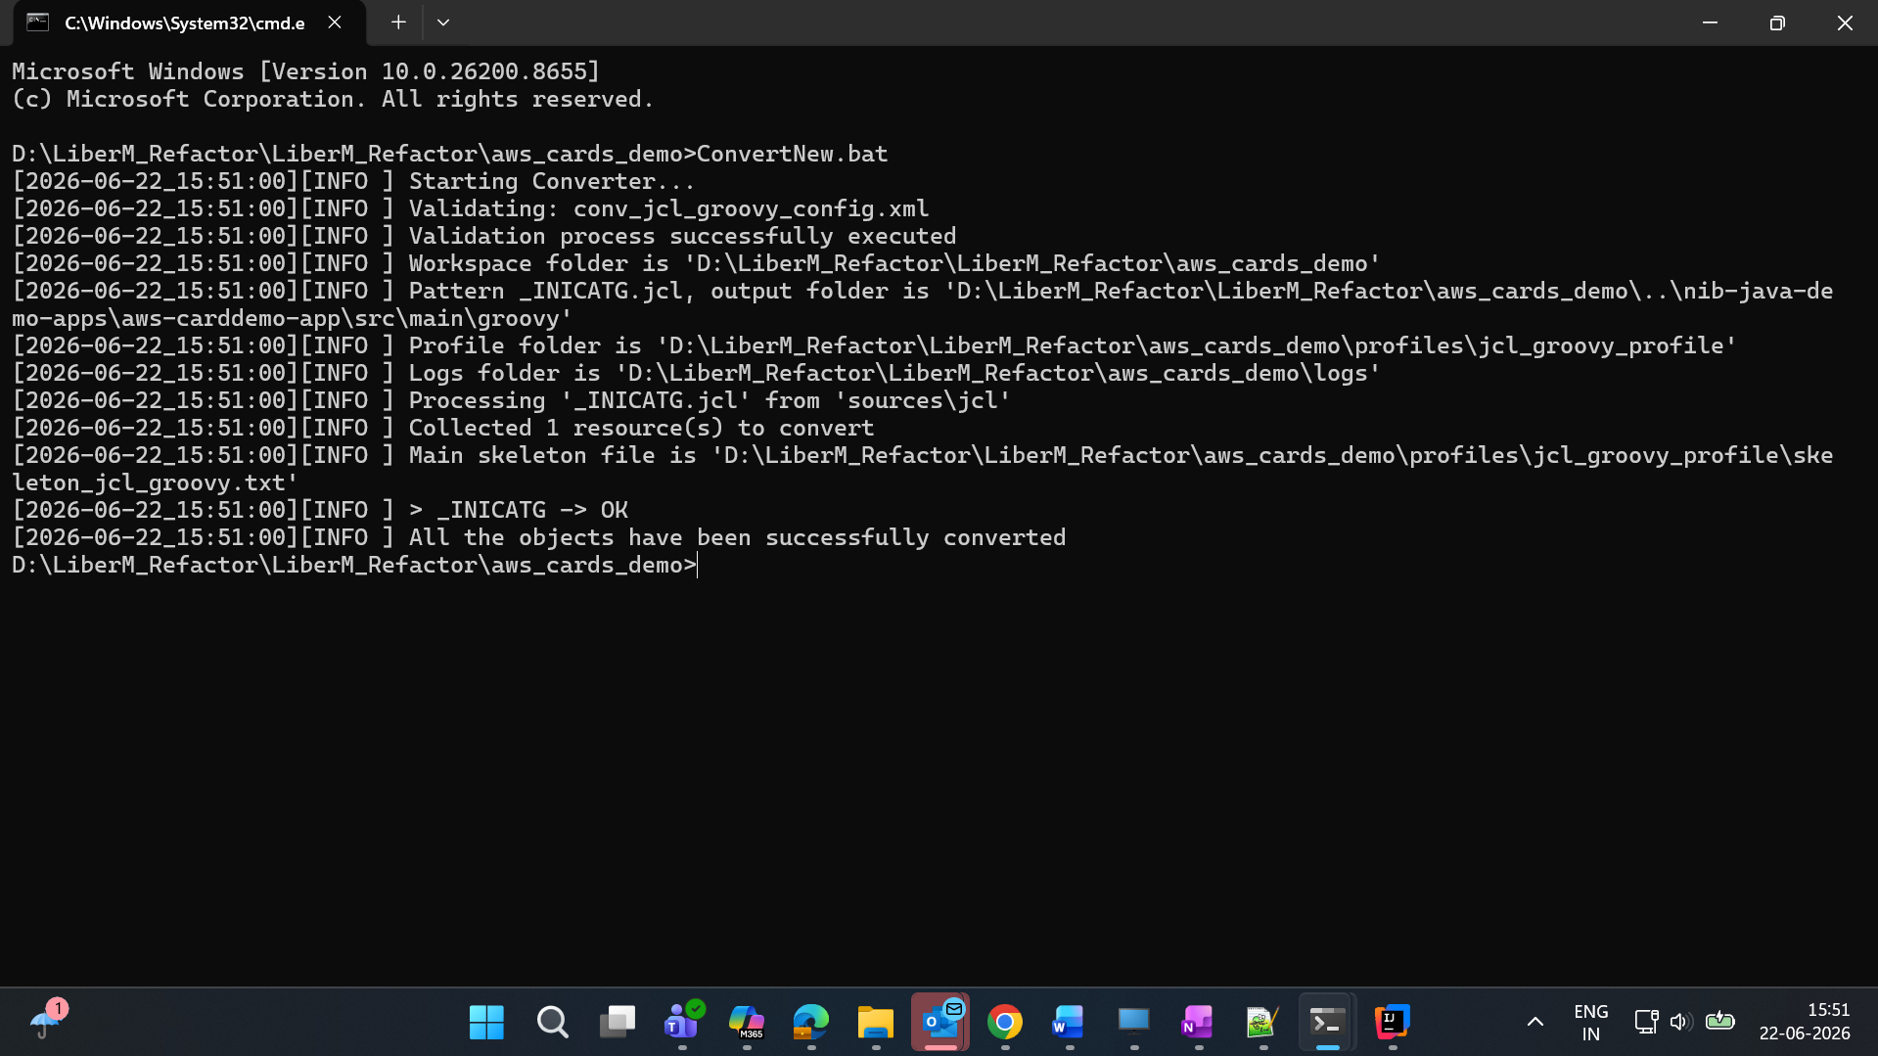

Figure 14: ConvertNew.bat running the JCL to Groovy conversion for the single specified file.

Verifying the Generated Output
- Confirm that the converted Groovy files are available in the configured output directory.
- Review the log files and verify that the conversion completed without any major errors or failures.
- Perform a functional comparison between the generated Groovy code and the original JCL logic to confirm that the business rules and processing flow have been preserved correctly.

CHAPTER 5

JCL to PowerShell Conversion
This chapter explains the prerequisites, folder structure, configuration, execution, output validation, and troubleshooting steps for converting JCL source files into PowerShell scripts using Liber*M Refactor, applied to the AWS Cards Demo v1.8.4 sample package.

What This Conversion Does
Liber*M Refactor modernizes legacy applications by converting mainframe artifacts such as JCL, BMS, and COBOL-related components into modern technology structures, including Java, Groovy, PowerShell, and Angular-based applications. This chapter covers the JCL-to-PowerShell configuration specifically.

Prerequisites
This conversion uses the same software and hardware prerequisites described in Chapter 2, Getting Started. In addition, obtain the aws_cards_demo_v1.8.4.zip package from your approved distribution location and extract it completely before starting.

Folder Structure Overview
Item | Description
aws_cards_demo_v1.8.4 | Source folder/package. Contains the input files and conversion configuration.
sources | Contains the JCL files that will be converted.
Convert.bat / ConvertNew.bat | Scripts used to start the conversion.
conv_jcl_pwsh_config.xml | XML configuration for JCL-to-PowerShell conversion.
logs | Contains conversion and execution logs.
nib-java-demo-apps-csharp | Target/output folder, generated automatically after conversion. It does not need to be created manually.
...\nib-dot-net\Samples\AwsCardsDemo\Scripts | Location where the generated PowerShell output can be reviewed.

Running the Conversion

Step 1: Open the Package
Open the aws_cards_demo_v1.8.4 folder.

Step 2: Verify the Source Files
Navigate to aws_cards_demo_v1.8.4\sources and verify that it contains the JCL input files that need to be converted.

Step 3: Verify the Conversion Files
In the aws_cards_demo_v1.8.4 folder, verify that Convert.bat (or ConvertNew.bat) and the XML configuration file, conv_jcl_pwsh_config.xml, are present.
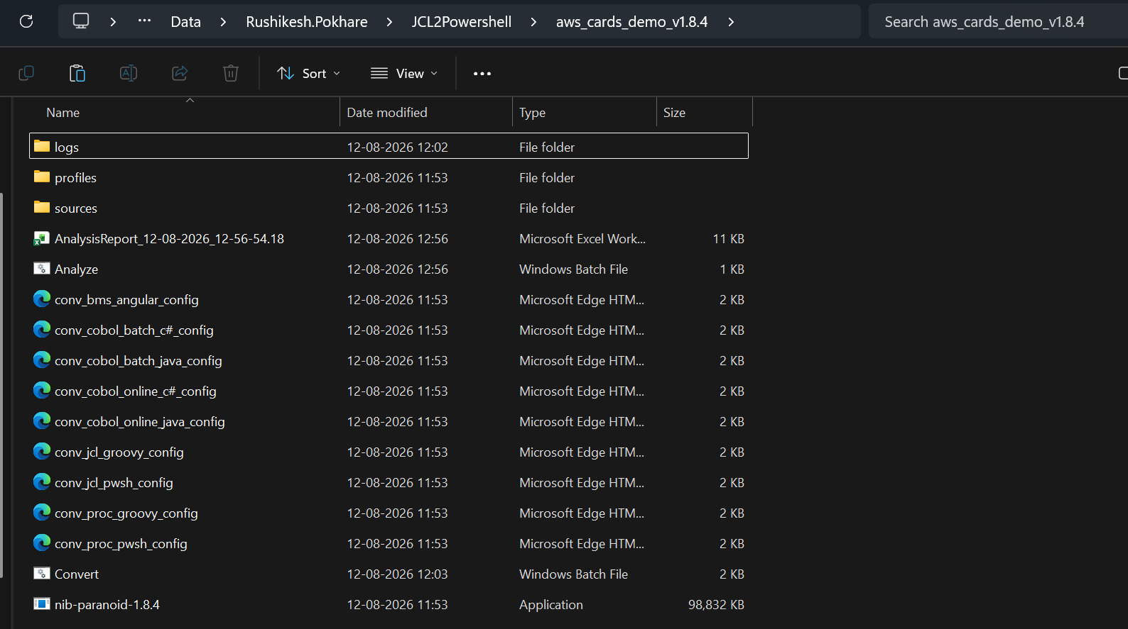

Figure 16: The aws_cards_demo_v1.8.4 package folder, showing the conversion scripts, configuration files, and the conversion engine.

Step 3a: Configure Convert.bat
Open Convert.bat in Notepad and uncomment only the conversion command required for the current task. For JCL to PowerShell conversion, the required line is:
%CTOOL% conv_jcl_pwsh_config.xml

Do not uncomment unrelated conversion commands unless they are required for the current task.
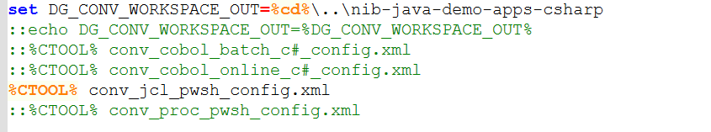

Figure 17: Convert.bat with the JCL to PowerShell conversion line enabled and unrelated conversion lines left commented out.

Step 3b: Verify the XML Configuration
Open conv_jcl_pwsh_config.xml in Notepad and verify the <resources> section.
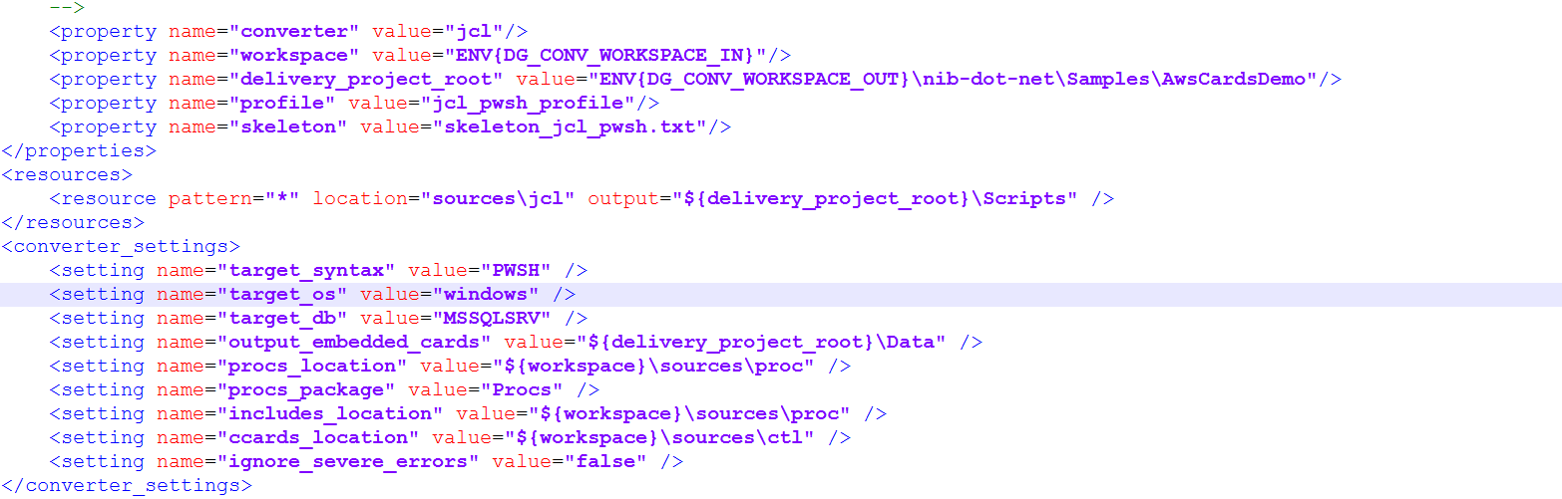

Figure 18: The conv_jcl_pwsh_config.xml configuration file, showing converter, workspace, and resource settings for the JCL to PowerShell conversion.
Attribute | Description
pattern="*" | Includes all matching files from the configured source folder.
location | Specifies the source location containing the input JCL files.
output | Defines the target location where the converted PowerShell files are generated.

The effective input/output workspace paths are controlled through variables used by the conversion batch script, including DG_CONV_WORKSPACE_IN and DG_CONV_WORKSPACE_OUT.

Step 4: Start the Conversion
Run Convert.bat or ConvertNew.bat. You can double-click the batch file, or open the package folder, type cmd in the File Explorer address bar, press Enter and execute the batch file from Command Prompt.

Figure 19: Convert.bat starting the JCL to PowerShell conversion from the Command Prompt.

Step 5: Wait for Completion
Allow the process to complete. Do not close the Command Prompt window while the conversion is running. Wait until a completion message appears or there is no further activity.

Figure 20: Command Prompt showing the conversion in progress.

Step 6: Verify the Generated Target Folder
After successful completion, the nib-java-demo-apps-csharp folder is automatically generated for the first time, corresponding to the aws_cards_demo_v1.8.4 package. The target folder does not need to be created manually.
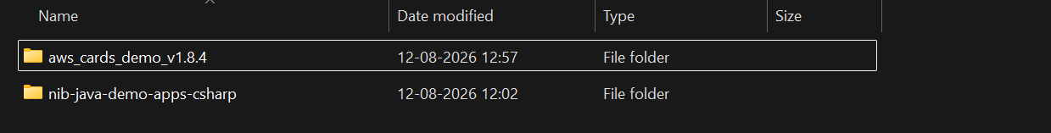

Figure 21: The automatically generated nib-java-demo-apps-csharp target folder alongside the source package.

Step 7: Verify the Generated PowerShell Files
Navigate to nib-java-demo-apps-csharp\nib-dot-net\Samples\AwsCardsDemo\Scripts and verify that the generated PowerShell scripts are present.
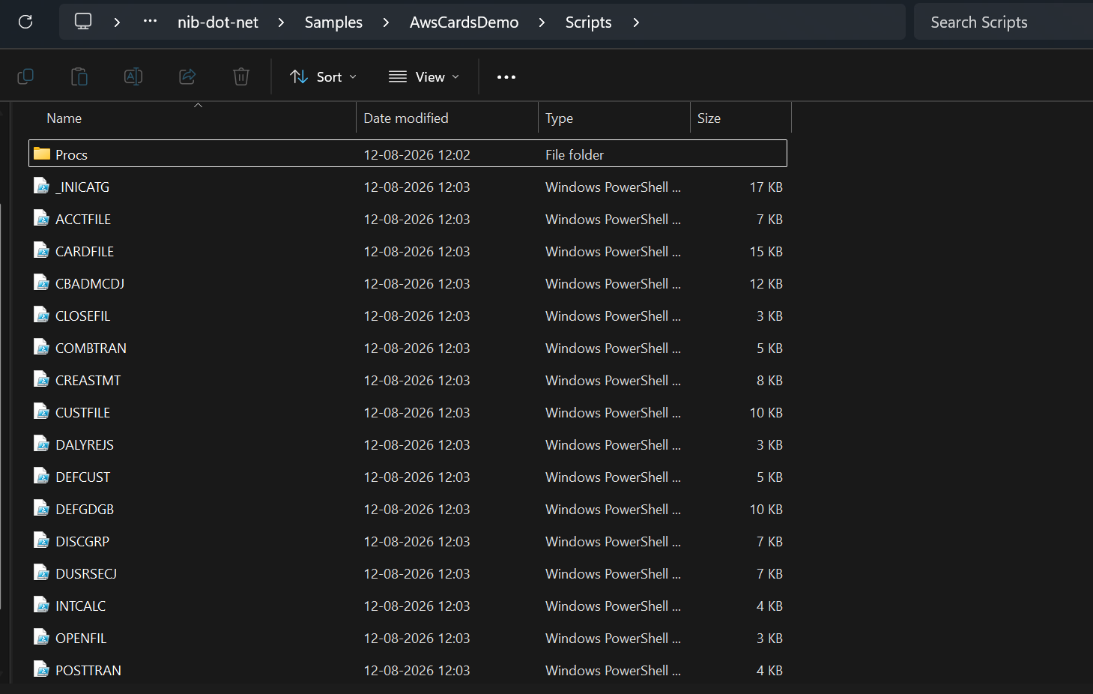

Figure 22: Generated PowerShell (.ps1) scripts in the Scripts output folder, one file per converted JCL program.

Step 8: Review the Generated Code
Review the generated PowerShell scripts and supporting files and make any required application-specific modifications or corrections.

Expected Conversion Output
For a successful JCL-to-PowerShell conversion, the generated output is available under the automatically created target structure. The primary PowerShell output can be reviewed under:
nib-java-demo-apps-csharp\nib-dot-net\Samples\AwsCardsDemo\Scripts

The exact files generated depend on the JCL input and the rules defined in the conversion configuration.

Validation Checklist
- The Liber*M package is extracted completely.
- Java JDK 8 or above is installed and configured.
- The required license key is available and valid.
- JCL source files are present under the sources folder.
- Convert.bat / ConvertNew.bat is available.
- conv_jcl_pwsh_config.xml is available.
- The JCL-to-PowerShell conversion command is uncommented.
- The XML source and output locations are verified.
- The conversion completes without errors.
- The target folder is generated automatically.
- Generated PowerShell files are present under the expected Scripts folder.
- Generated code has been reviewed and tested.
- Logs have been checked if any conversion issue occurred.

Important Notes
- Do not manually create the target folder before conversion unless specifically required by the project configuration.
- Do not close the conversion Command Prompt window while the conversion is running.
- Only enable the required conversion command in Convert.bat.
- Always verify the XML resource configuration before running the conversion.
- Generated PowerShell code should be reviewed and tested before being used in a production environment.
- Keep the original JCL source files unchanged so the generated output can be compared against the source behaviour.
- Use the logs and the Analyze.bat report as the first point of investigation when conversion errors occur.

Quick Start Summary
JCL Source → XML Config → Liber*M Engine → Generated Output → Review & Test
- Put JCL files in sources
- Enable conv_jcl_pwsh_config.xml in Convert.bat
- Run Convert.bat
- Verify the generated Scripts output

CHAPTER 6

PROCLIB to PowerShell Conversion
This chapter describes how to convert PROCLIB (.prc) source files into PowerShell using the Liber*M Refactor conversion utility (ConvertNew.bat).

Overview
Before starting the conversion, ensure that the aws_cards_demo_v1.8.4 package has been extracted successfully and all required folders and files are available. The conversion is initiated from the aws_cards_demo folder, while the generated PowerShell code is stored in the nib-java-demo-apps-csharp project.
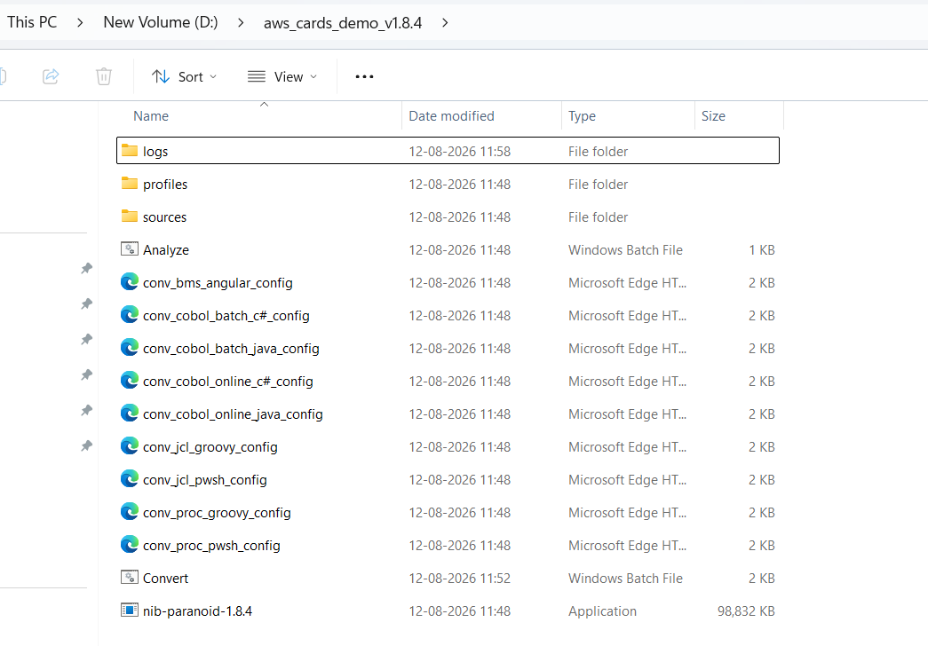

Figure 26: The aws_cards_demo_v1.8.4 package folder, showing the conversion engine, configuration files, and supporting folders used for PROCLIB to PowerShell conversion.
For PROCLIB to PowerShell conversion, the primary components used are:
Item | Description
ConvertNew.bat | Starts the PROCLIB to PowerShell conversion process.
conv_proc_pwsh_config.xml | Configuration file for PROCLIB to PowerShell conversion.
logs | Stores log files generated during the conversion.
nib-paranoid-1.8.4.exe | Main conversion engine that performs the code conversion.

The nib-java-demo-apps-csharp folder is the output project where the converted code is generated. After a successful conversion, the generated PowerShell files are stored in the appropriate folder inside this project.
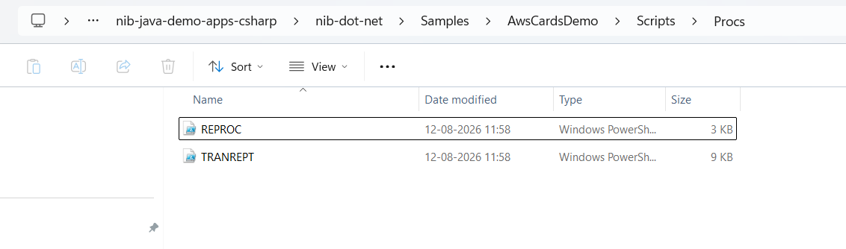

Figure 27: The nib-java-demo-apps-csharp target project, showing the generated PowerShell scripts under Scripts\Procs.

Conversion Procedure

Step 1: Extract the Package
Extract aws_cards_demo_v1.8.4.zip if you have not already done so.

Step 2: Verify the Source Files
All PROCLIB files are present in aws_cards_demo\sources\proc. These are the PROCLIB programs that need to be converted.

Step 3: Verify the Configuration File
Open conv_proc_pwsh_config.xml and verify the source location and output path (${delivery_project_root}).

Figure 28: The <resources> element of conv_proc_pwsh_config.xml, showing the pattern, location, and output attributes.

Step 4: Enable the Configuration
Open ConvertNew.bat and ensure the PROCLIB configuration (conv_proc_pwsh_config.xml) is enabled.
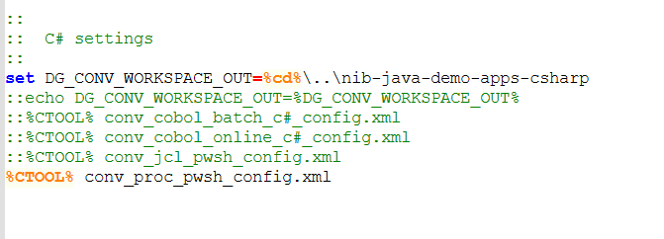

Figure 29: ConvertNew.bat with the PROCLIB to PowerShell configuration line enabled.

Step 5: Run the Conversion
Run ConvertNew.bat. The batch file initializes the workspace, validates the license, and invokes the Liber*M conversion engine.
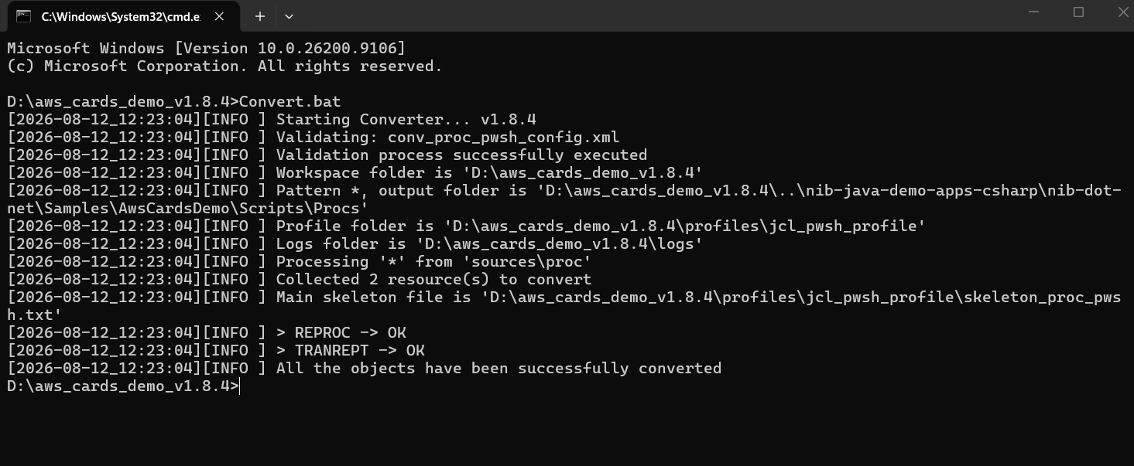

Figure 30: ConvertNew.bat running the PROCLIB to PowerShell conversion, with a successful completion message in the Command Prompt window.
Monitor the logs folder for execution status, then verify that the converted PowerShell files are generated in nib-java-demo-apps-csharp\nib-dot-net\Samples\AwsCardsDemo\Scripts\Procs.

Configuration Reference
The conv_proc_pwsh_config.xml file controls the conversion. The following attributes are important:
Attribute | Description
pattern='*' | Converts all PROCLIB programs.
pattern='TR*' | Converts PROCLIB programs whose names start with TR.
location='sources\proc' | Source folder containing PROCLIB (.prc) files.
output='${delivery_project_root}...' | Destination folder for the generated PowerShell code.

Output Validation
- PowerShell source files should be generated.
- No critical errors should appear in the logs folder.
- Compare the generated PowerShell logic with the original PROCLIB program to validate the conversion.

For guidance that applies to all conversion types, see Chapter 10, Common Troubleshooting.

CHAPTER 7

PROCLIB to Groovy Conversion
This chapter describes how to convert PROC (.prc) source files into Groovy using the Liber*M Refactor conversion utility (ConvertNew.bat).

Overview
Before starting the conversion, ensure that the Liber*M Refactor package has been extracted successfully and that both the aws_cards_demo and nib-java-demo-apps folders are available. The conversion is initiated from the aws_cards_demo folder, while the generated Groovy code is stored in the nib-java-demo-apps project.

Figure 31: The Liber*M Refactor package folder, showing the aws_cards_demo source folder and nib-java-demo-apps target folder.
The aws_cards_demo folder is the main workspace for the conversion process. For PROC to Groovy conversion, the primary components used are:
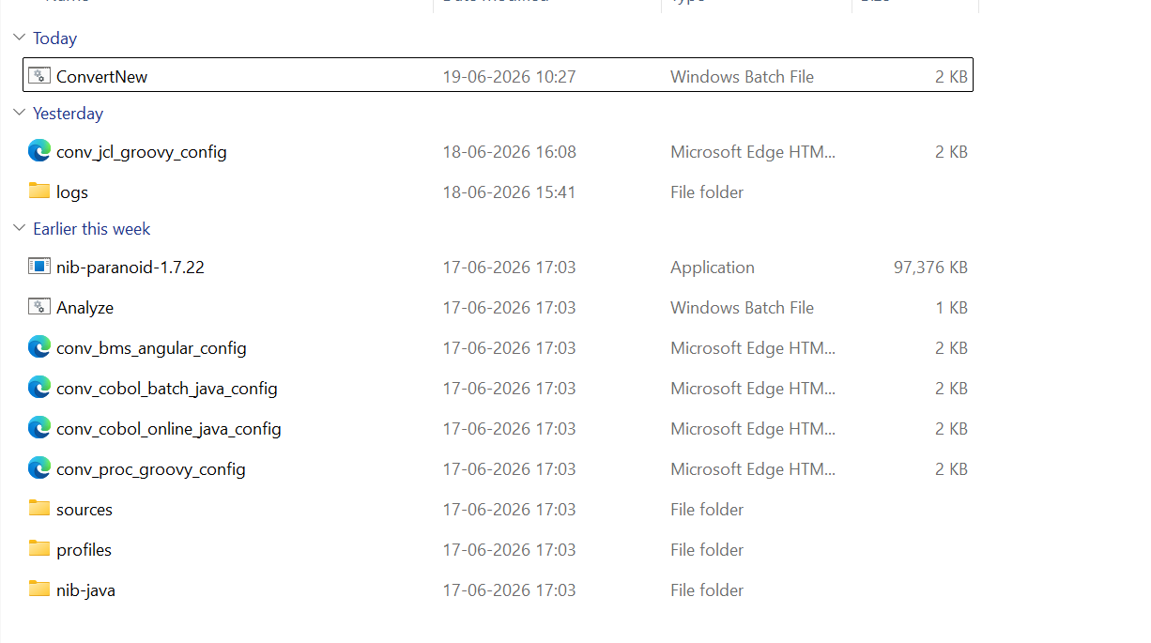

Figure 32: Contents of the aws_cards_demo folder, showing the conversion scripts, configuration files, and supporting resources.
Item | Description
ConvertNew.bat | Starts the PROC to Groovy conversion process.
conv_proc_groovy_config.xml | Configuration file for PROC to Groovy conversion.
logs | Stores log files generated during the conversion.
nib-paranoid-1.7.22.exe | Main conversion engine that performs the code conversion.

The nib-java-demo-apps folder is the output project where the converted code is generated. It contains the Java/Groovy application structure, including source code, configuration files, and project resources. After a successful conversion, the generated Groovy files are stored in the appropriate folder inside this project.
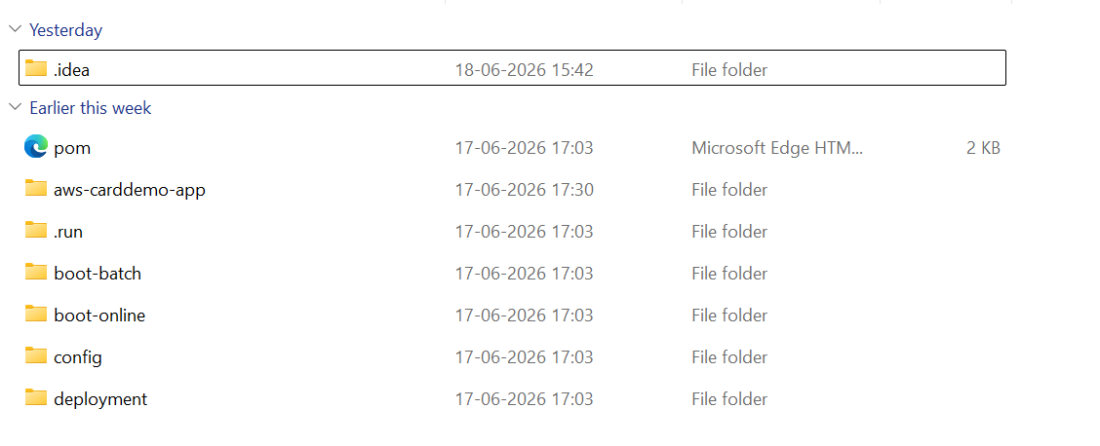

Figure 33: The nib-java-demo-apps target project structure.

Conversion Procedure

Step 1: Extract the Package
Extract Liber*M_Refactor.zip if you have not already done so.

Step 2: Verify the Source Files
All PROC files are present in aws_cards_demo\sources\proc. These are the programs that need to be converted.

Step 3: Verify the Configuration File
Open conv_proc_groovy_config.xml and verify the source location and output path (${delivery_project_root}).

Figure 34: The <resources> element of conv_proc_groovy_config.xml.

Step 4: Enable the Configuration
Open ConvertNew.bat and ensure the PROC configuration (conv_proc_groovy_config.xml) is enabled.
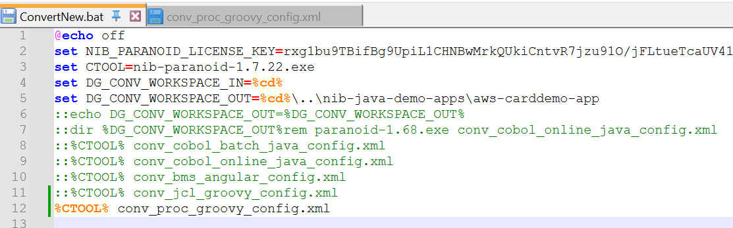

Figure 35: ConvertNew.bat with the PROC to Groovy configuration line enabled.

Step 5: Run the Conversion
Run ConvertNew.bat. The batch file initializes the workspace, validates the license, and invokes the Liber*M conversion engine.
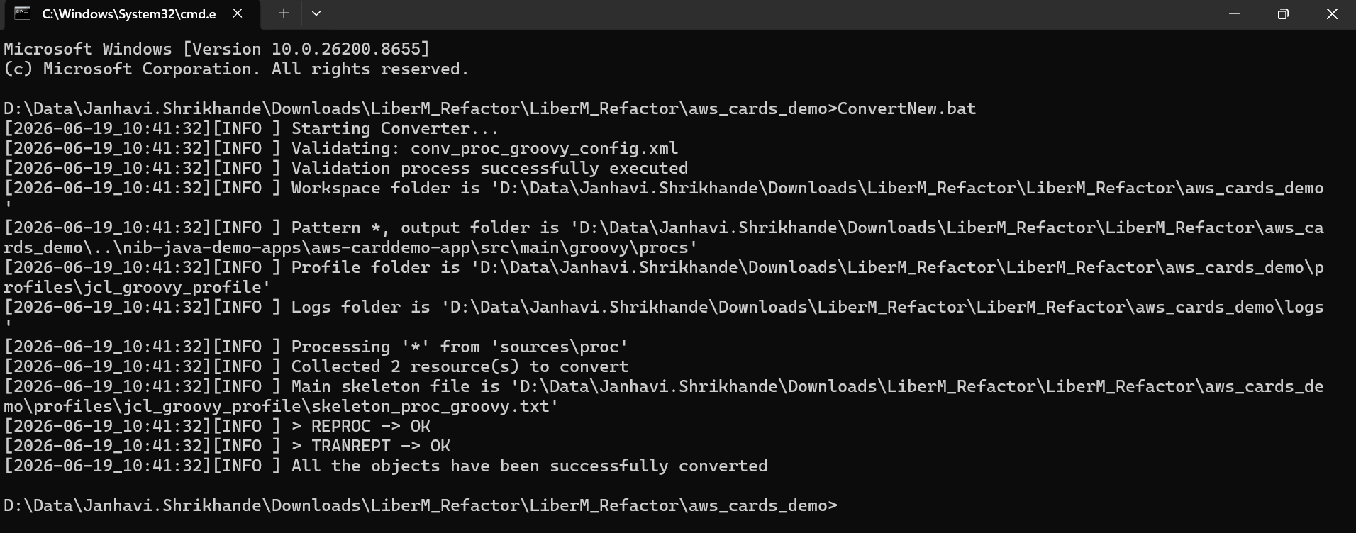

Figure 36: ConvertNew.bat running the PROC to Groovy conversion, with a successful completion message.
- Monitor the logs folder for execution status.
- Verify that the converted Groovy files are generated in nib-java-demo-apps\src\main\groovy\procs.

Configuration Reference
The conv_proc_groovy_config.xml file controls the conversion. The following attributes are important:
Attribute | Description
pattern='*' | Converts all PROC files.
pattern='TR*' | Converts PROC programs whose names start with the same characters (for example, TR).
location='sources\proc' | Source folder containing .prc files.
output='${delivery_project_root}...' | Destination folder for the generated Groovy code.

Output Validation
- Groovy source files should be generated.
- No critical errors should appear in the logs folder.
- Compare the generated Groovy logic with the original PROC program to validate the conversion.
For guidance that applies to all conversion types, see Chapter 10, Common Troubleshooting.

CHAPTER 8

BMS/CICS/MFS to JSON/HTML/TypeScript Conversion
This chapter explains, in practical steps, how to use the Liber*M Refactor tool to convert BMS map sets into JSON, HTML, and TypeScript, and how to convert the related CICS COBOL Online business logic into Java.

What This Conversion Does
Liber*M Refactor converts legacy objects such as JCL, BMS, and COBOL-related components into modern technologies such as Java, Groovy, and Angular-based structures. This chapter covers the BMS-to-Angular (JSON/HTML/TypeScript) configuration, and the related COBOL Online-to-Java configuration used for CICS business logic.

Prerequisites
This conversion uses the same software and hardware prerequisites described in Chapter 2, Getting Started, together with a reliable internet connection for downloading dependencies and updates.

Folder Structure Overview
When you extract the Liber*M_Refactor package, you will see two important folders:
- aws-cards-demo (or aws_cards_demo) — the SOURCE folder.
- nib-java-demo-apps — the TARGET folder.
All conversions happen from the source folder and are generated into the target folder.

Converting BMS Map Sets to JSON/HTML/TypeScript

Step 1: Open the Source Folder
Open the aws_cards_demo folder.

Step 2: Verify the Source Files
Navigate to the source folder (aws_cards_demo\sources) and verify that it contains the input files you want to convert.

Step 3: Configure the Conversion
Verify that the Convert.bat / ConvertNew.bat file and the XML configuration file (for example, conv_bms_angular_config.xml) are present in the aws_cards_demo folder.
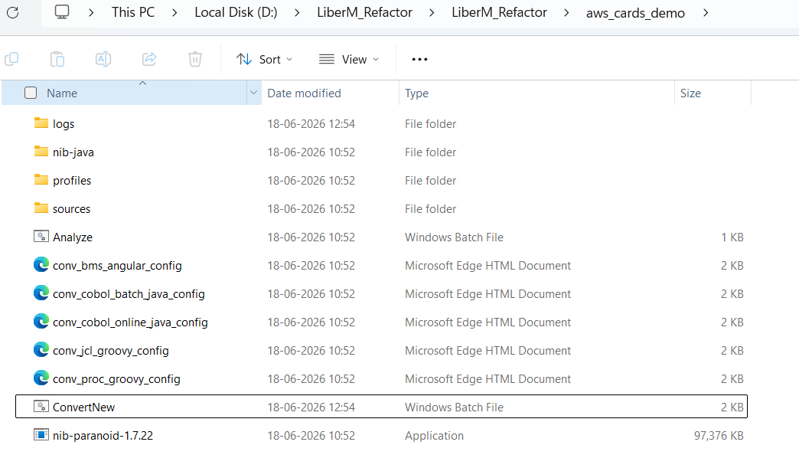

Figure 37: The aws_cards_demo folder, showing the conversion scripts, configuration files, and supporting folders used for BMS conversion.
Open Convert.bat / ConvertNew.bat in Notepad and uncomment the line for the required conversion type. In this example, conv_bms_angular_config.xml is uncommented.
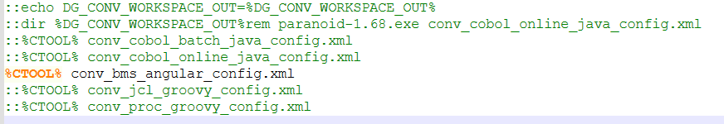

Figure 38: Convert.bat / ConvertNew.bat with the conv_bms_angular_config.xml conversion line enabled.
Open the corresponding .xml file in Notepad and verify the <resources> section.

Figure 39: The <resources> element of the BMS-to-Angular configuration file.
Attribute | Description
pattern="*" | Includes all files from the source folder.
location | Specifies the source path.
output | Defines the target folder where the converted files will be generated.

The output path is also controlled through the DG_CONV_WORKSPACE_IN and DG_CONV_WORKSPACE_OUT variables in ConvertNew.bat.

Step 4: Run the Conversion
Run Convert.bat / ConvertNew.bat (double-click it, or open the folder, type cmd in the address bar, press Enter, and execute it). Once started, the tool automatically converts all configured objects.

Figure 40: Convert.bat / ConvertNew.bat starting the BMS conversion from the Command Prompt.

Step 5: Wait for Completion
Wait for the process to complete. Do not close the window until a completion message appears or there is no further activity.

Figure 41: Command Prompt showing a successful completion message after the BMS conversion finishes.

Step 6: Verify the Generated Output
After completion, go to the target folder nib-java-demo-apps\aws-carddemo-app\src\main\resources and verify that the converted files are generated.
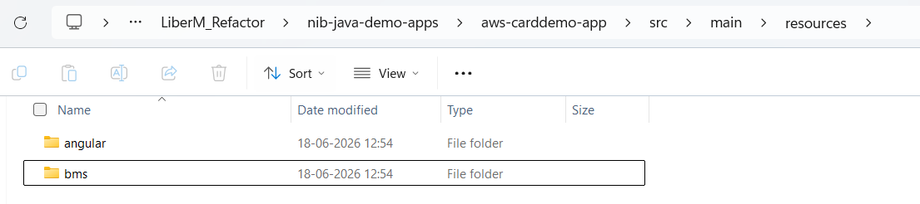

Figure 42: The target resources folder, containing the bms and angular output folders.
In the bms folder, JSON files are stored; in the angular folder, TypeScript (.ts) and HTML files are stored, as shown below.
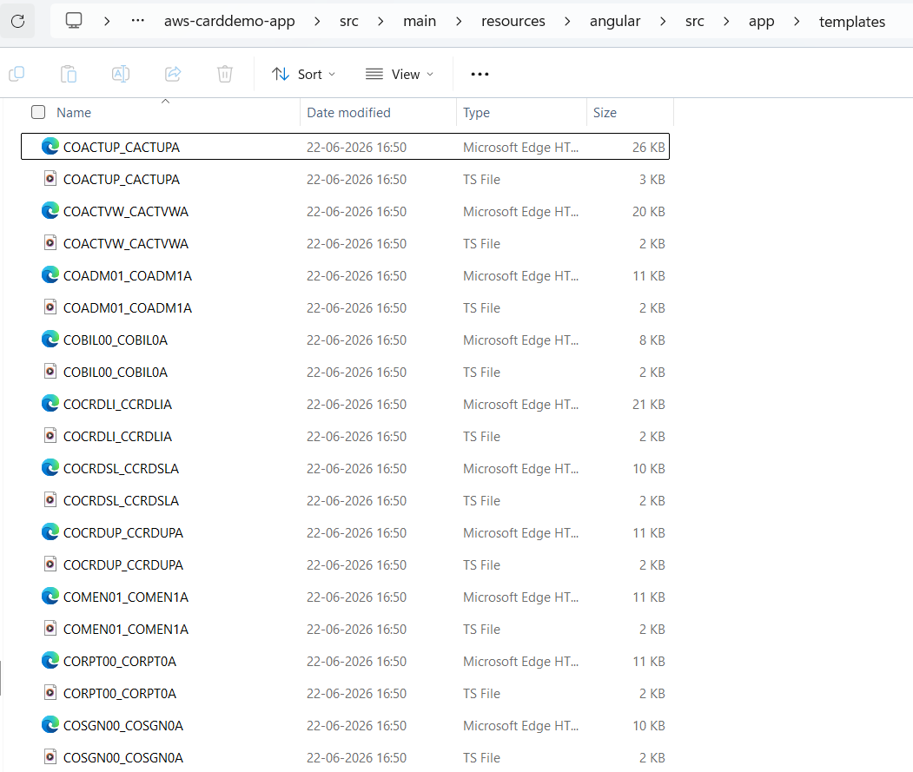

Figure 43: Generated JSON files in the bms output folder.
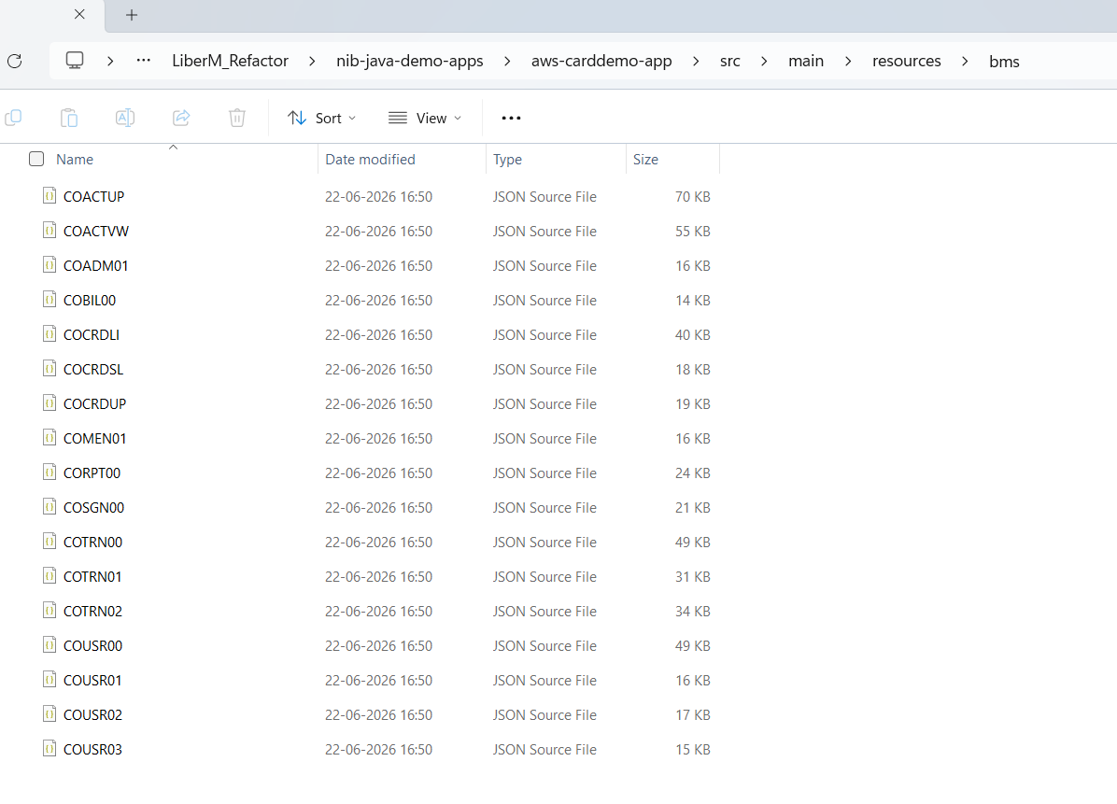

Figure 44: Generated TypeScript and HTML files in the angular output folder.

Step 7: Review the Generated Code
Review the generated code and make any required modifications.

Converting CICS COBOL Online Programs to Java
In CICS applications, the core business logic is typically implemented in COBOL programs (.cbl files). These COBOL programs can be converted into Java (.java) files using the same package and workflow used for the BMS conversion above.
- Use the conv_cobol_online_java_config.xml configuration file to perform the conversion.
- Open ConvertNew.bat in Notepad and uncomment the line corresponding to conv_cobol_online_java_config.xml.
- Open conv_cobol_online_java_config.xml and verify the <resources> section.
- Save the changes and run ConvertNew.bat.
- After the conversion completes successfully, verify that the generated .java files are available in the configured output directory.
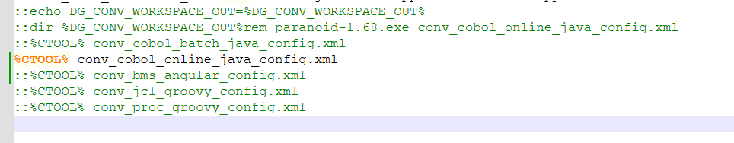

Figure 46: ConvertNew.bat with the conv_cobol_online_java_config.xml conversion line enabled.

Figure 47: The <resources> element of conv_cobol_online_java_config.xml.
Attribute | Description
pattern="CO*" | Includes all files whose names begin with CO — the naming convention used for online programs.
location | Specifies the source folder containing the COBOL (.cbl) files.
output | Specifies the destination folder where the generated Java (.java) files will be stored.

The generated Java files are written under nib-java-demo-apps\aws-carddemo-app\src\main\java\com\aws\carddemo\online\program.
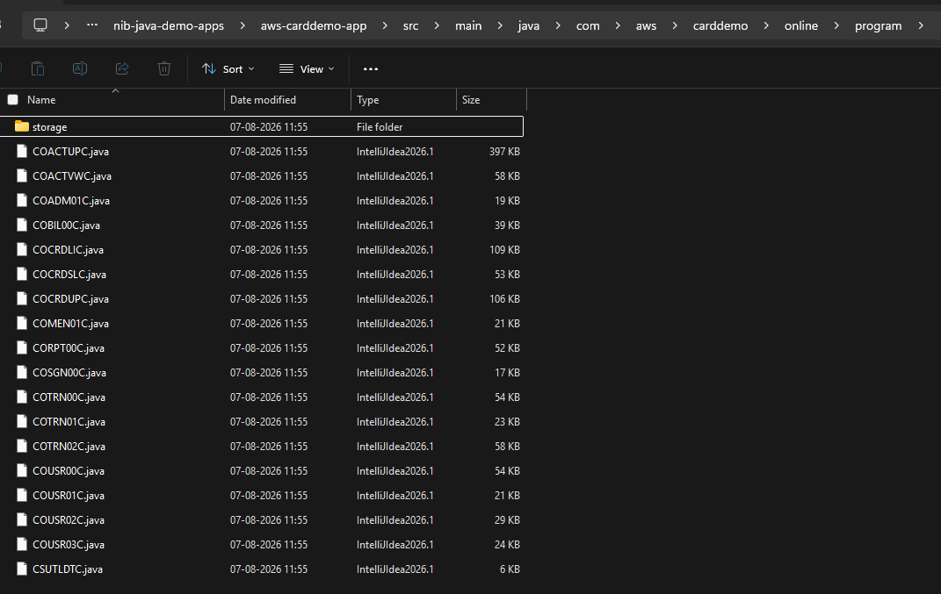

Figure 48: Generated Java (.java) files in the CICS Online program output folder.

CHAPTER 9

COBOL to Java Conversion
This chapter documents the end-to-end process of converting the Cobol to Java, building and deploying it locally, and validating both online (transaction-based) and batch processing through the Liber*M Refactor / Supernaut and Motorhead framework. Unlike the conversions in the previous chapters, this conversion path also covers building the generated Java application and running it, since validating a COBOL-to-Java conversion normally requires seeing the converted application actually process an online transaction or a batch tn3270 job.

What This Chapter Covers
- Converting COBOL sources to Java and importing the result into IntelliJ IDEA
- Building the project with Maven, including a known Angular/npm build issue and its fix
- Starting the required services with Docker Compose
- Testing online transactions via the TN3270 emulator and via the Angular web UI
- Testing batch jobs (boot-batch) via Postman, Swagger UI, and cURL
- Setting up local debugging for the online and Angular applications

Prerequisites
This conversion uses the same base prerequisites described in Chapter 2, Getting Started. In addition, the build, deployment, and testing steps in this chapter require:
- Node.js — required for the Angular (web UI) build
- Docker Desktop, installed and running
- IntelliJ IDEA
- Postman — for batch job testing
- A TN3270 terminal emulator — for online transaction testing
TN3270Plus.zip

Running the COBOL to Java Conversion
Run the converter against the COBOL sources using Convert.bat, following the general workflow described in Chapter 2. For COBOL to Java, the converter validates each configuration file and converts the batch, online, and procedure resources in turn, using the following configuration files:
Configuration File | Converts
conv_cobol_batch_java_config.xml | COBOL batch programs to Java
conv_cobol_online_java_config.xml | COBOL online (CICS) programs to Java
conv_proc_groovy_config.xml | PROC members to Groovy, for use by the batch framework

Note: The full console output of a conversion run — including validation of all three configuration files and the per-object conversion status (for example, CBACT01C -> OK) for every batch, online, and procedure resource — is captured in the conversion.log reference log that ships with this guide.

Importing and Building the Converted Project

Importing the Project into IntelliJ
Open IntelliJ IDEA and import the converted project (nib-java-demo-apps) as a Maven project.
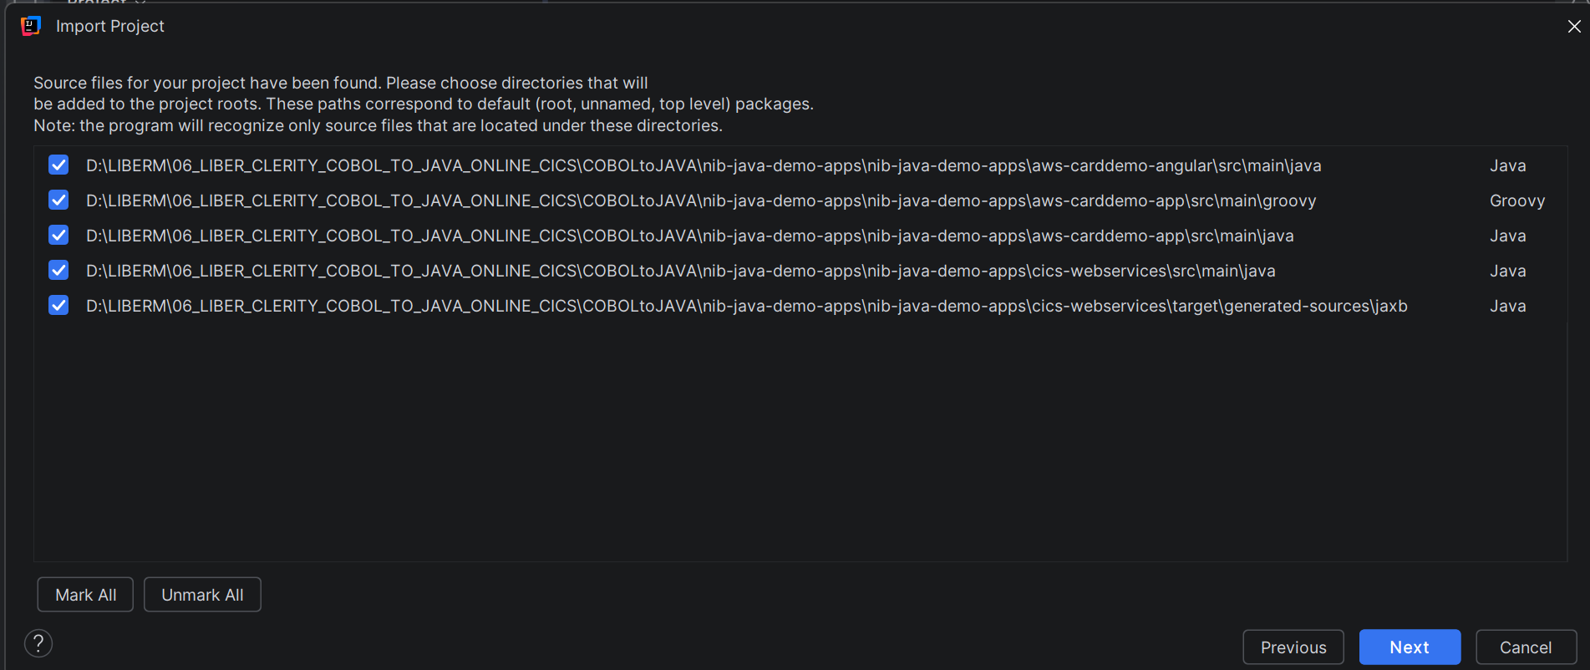

Figure 52: Importing the converted project into IntelliJ IDEA as a Maven project.

Building with Maven
Run a Maven clean install and confirm the build reaches BUILD SUCCESS.
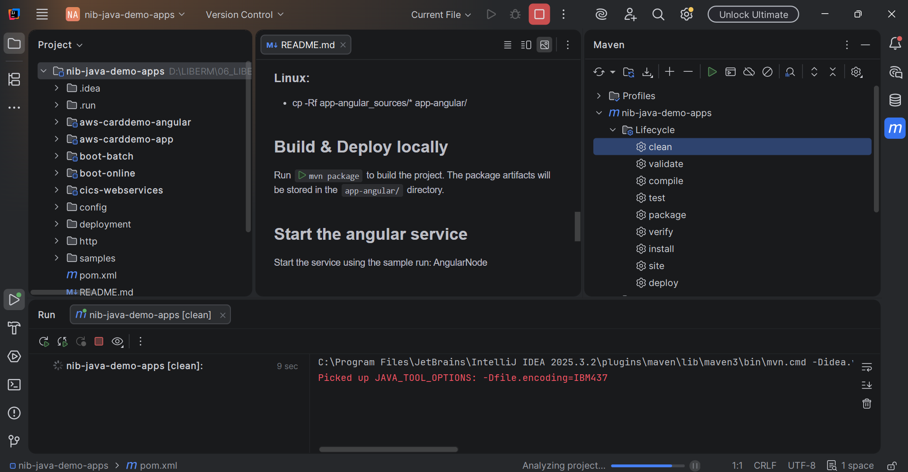

Figure 53: Maven clean install in progress.
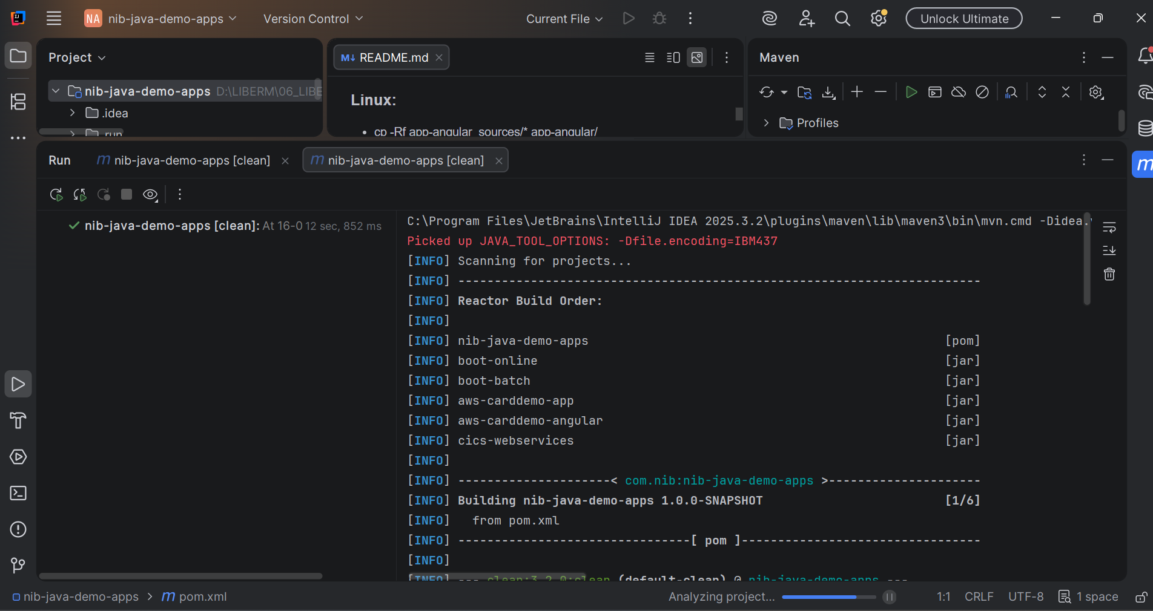

Figure 54: Maven build continuing through the project modules.
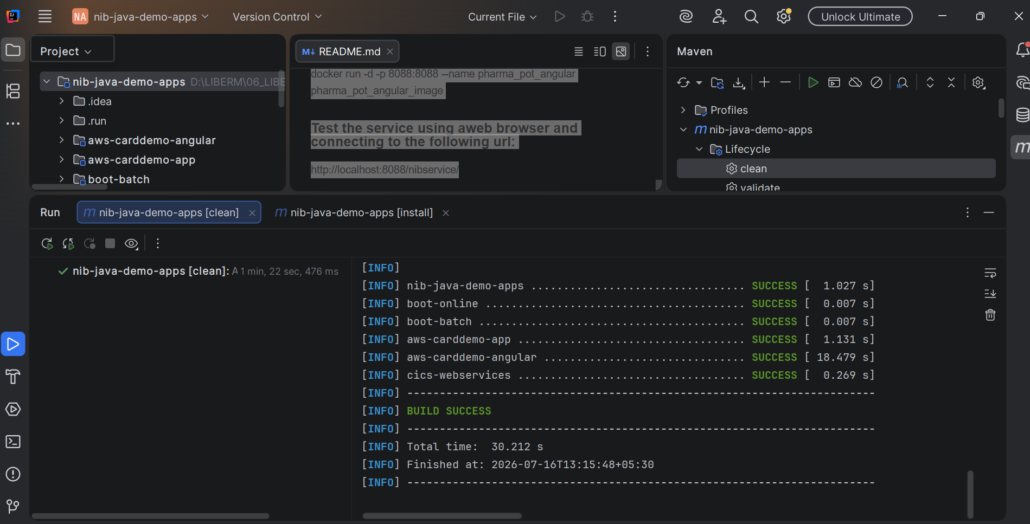

Figure 55: Maven build completing with BUILD SUCCESS.

Resolving the Angular Build Failure (Missing Node.js)
Known Issue: The Angular module build fails and the REST jar is skipped if Node.js is not installed on the machine.
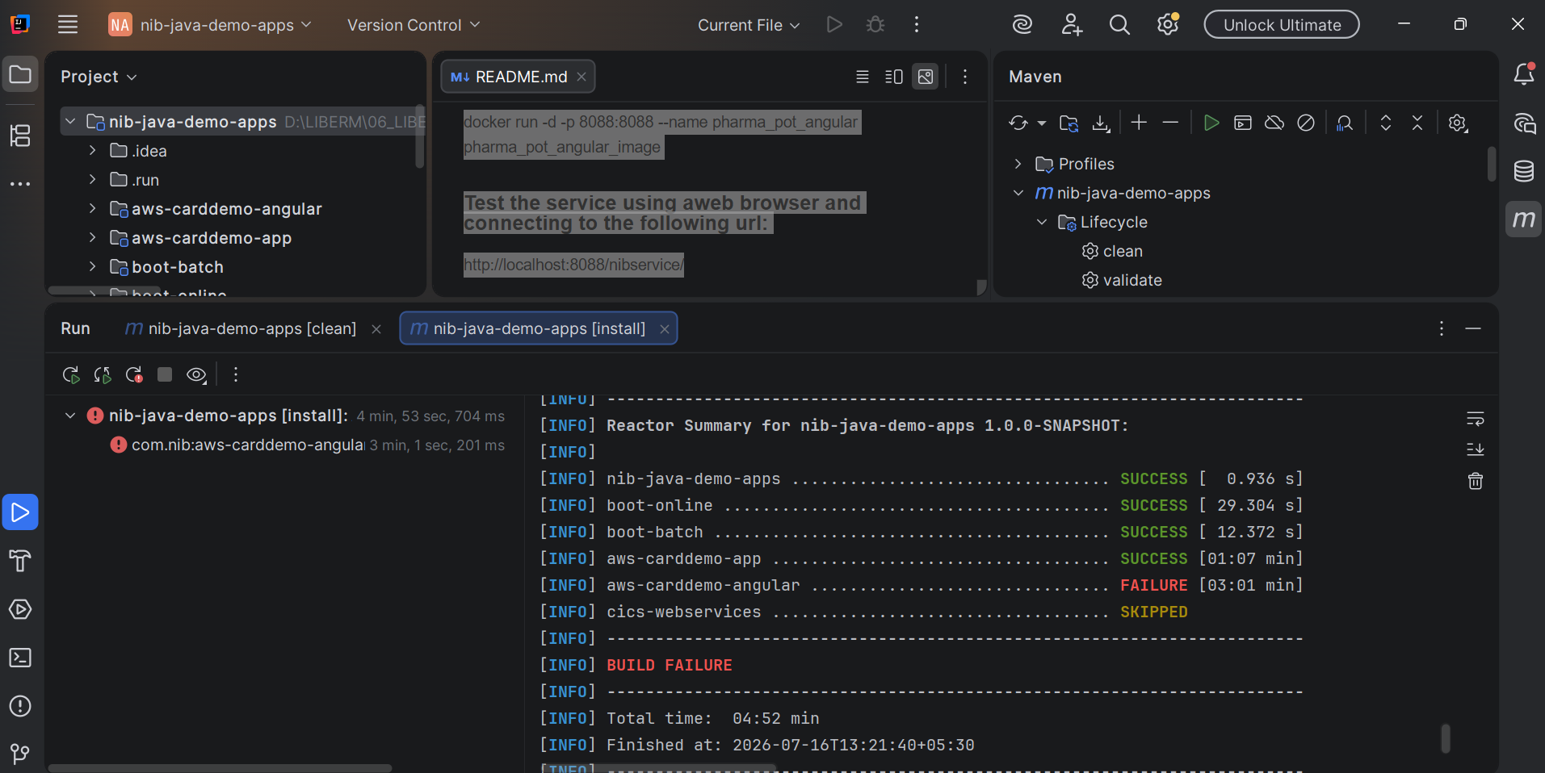

Figure 56: Build failure: the Angular module fails and the REST jar is skipped.
The specific error is an Angular peer-dependency conflict:
npm error peer @angular/common@"20.1.8" from @angular/animations@20.1.8

- Install Node.js if it is not already installed.
- Update the Angular animation packages: npm install @angular/animations@^21.0.0 --save
- Install the remaining required packages: npm install zone.js ngx-spinner@21.0.0 --save
Important: A plain npm install is not sufficient — Maven re-runs npm install with a different version during the build and silently overwrites this manual fix.

To make the fix permanent, pin the correct package versions by adding the install arguments to the app-angular frontend-maven-plugin configuration in pom.xml:
<configuration>
<workingDirectory>${project.basedir}/app-angular</workingDirectory>
<arguments>install @angular/animations@^21.0.0 zone.js
ngx-spinner@21.0.0 --save</arguments>
</configuration>

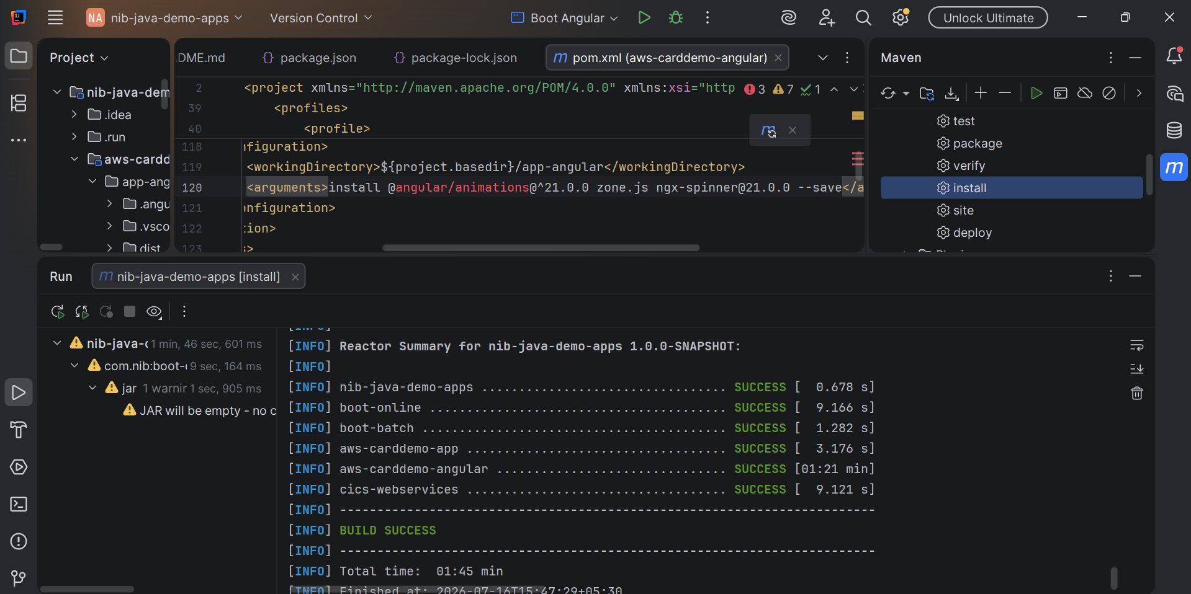

Figure 57: pom.xml updated with the pinned npm install arguments.

Starting Application Services with Docker

Starting Docker Compose Services
The application services are started from the deployment\docker-compose directory.
Common Error: Running docker compose up from the wrong directory produces: "no configuration file provided: not found".
- Open the deployment\docker-compose folder and open a terminal from there — not from the project root.
- Run docker compose up from that folder.
PS ...\nib-java-demo-apps\deployment\docker-compose> docker compose up

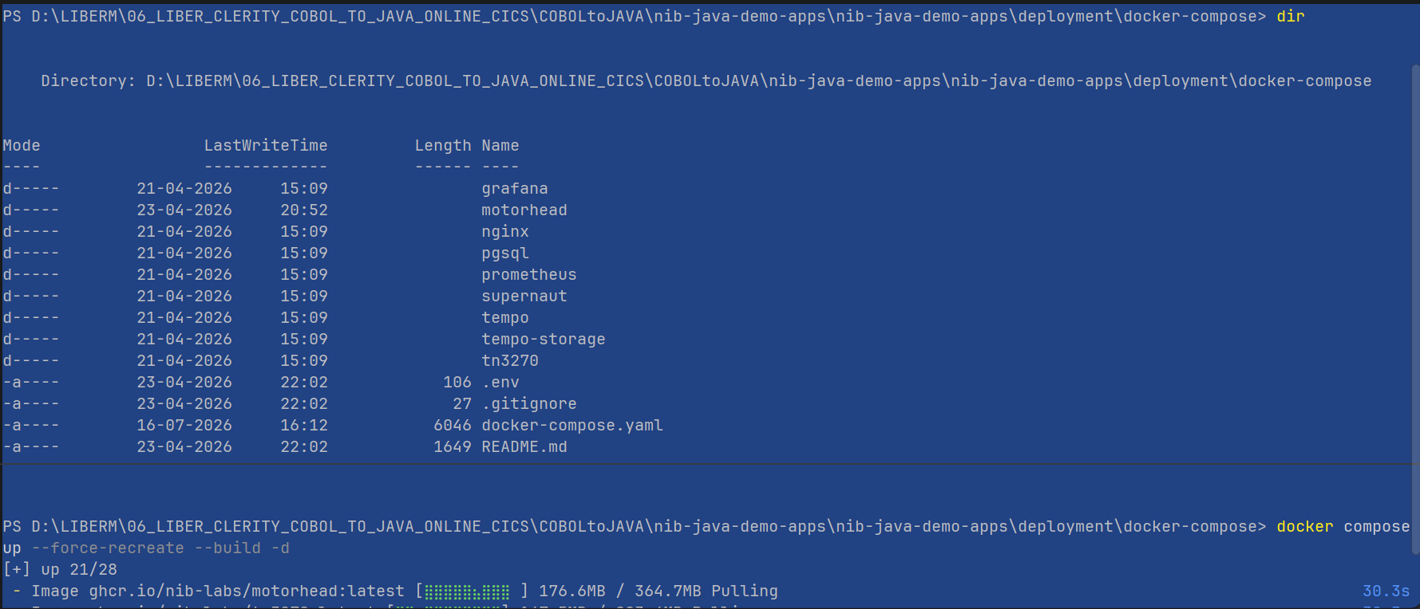

Figure 58: Opening a terminal from the docker-compose folder.
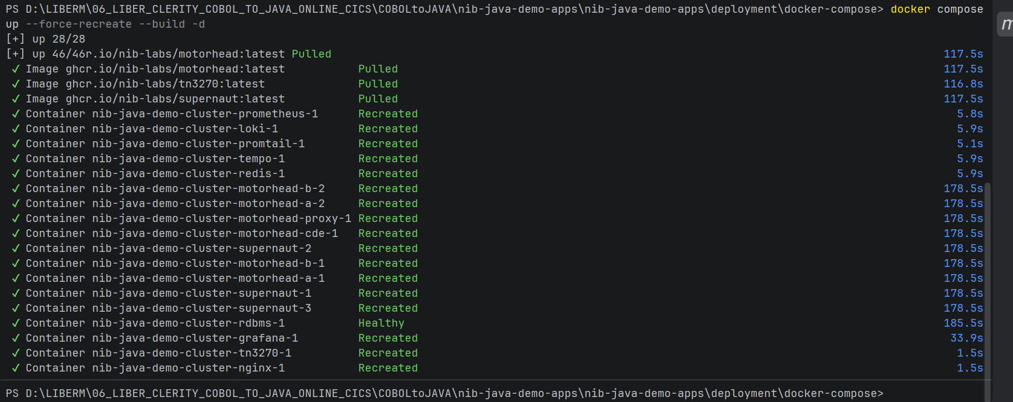

Figure 59: docker compose up running successfully from the correct folder.

Verifying Services in Docker Desktop
Confirm that all containers are shown as running in Docker Desktop. If any service is not up, start it manually from Docker Desktop.
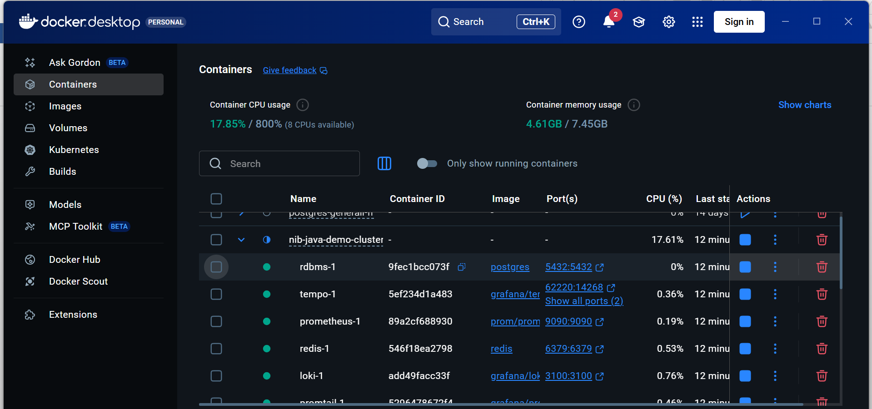

Figure 60: All required Docker services running in Docker Desktop.

Testing Online Transactions
Online transactions can be invoked in either of two ways: through a TN3270 emulator, which provides a UI similar to the mainframe environment, or through the Angular web UI, a modern browser-based interface to the same application.

Method 1: TN3270 Emulator
- Open the TN3270 emulator and connect.
- Go to Advanced settings and configure the terminal size.
- Open the keyboard panel and clear the input field so a transaction ID can be entered.
- After entering transaction ID CC00, the login screen appears. Log in with user0001 and the corresponding password.
- From the main menu, select an option.
- Selecting the account view option displays the account view menu.
- Enter an 11-digit account number to view its details.
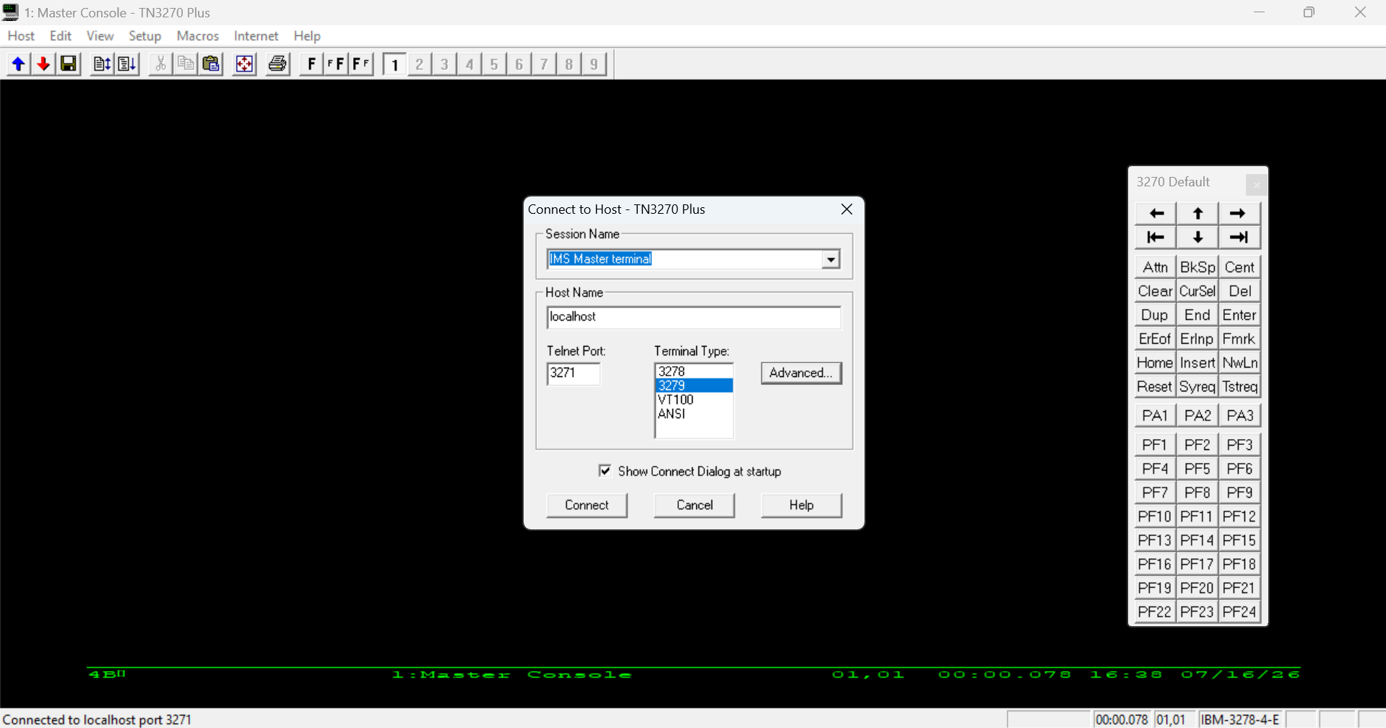

Figure 61: TN3270 emulator.
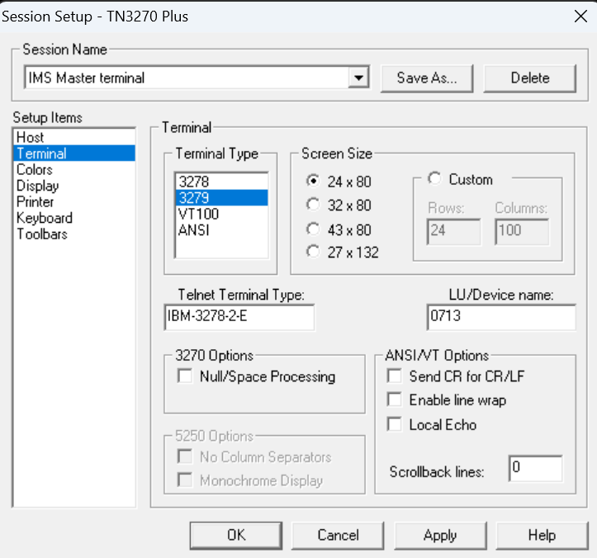

Figure 62: Advanced terminal size setup.
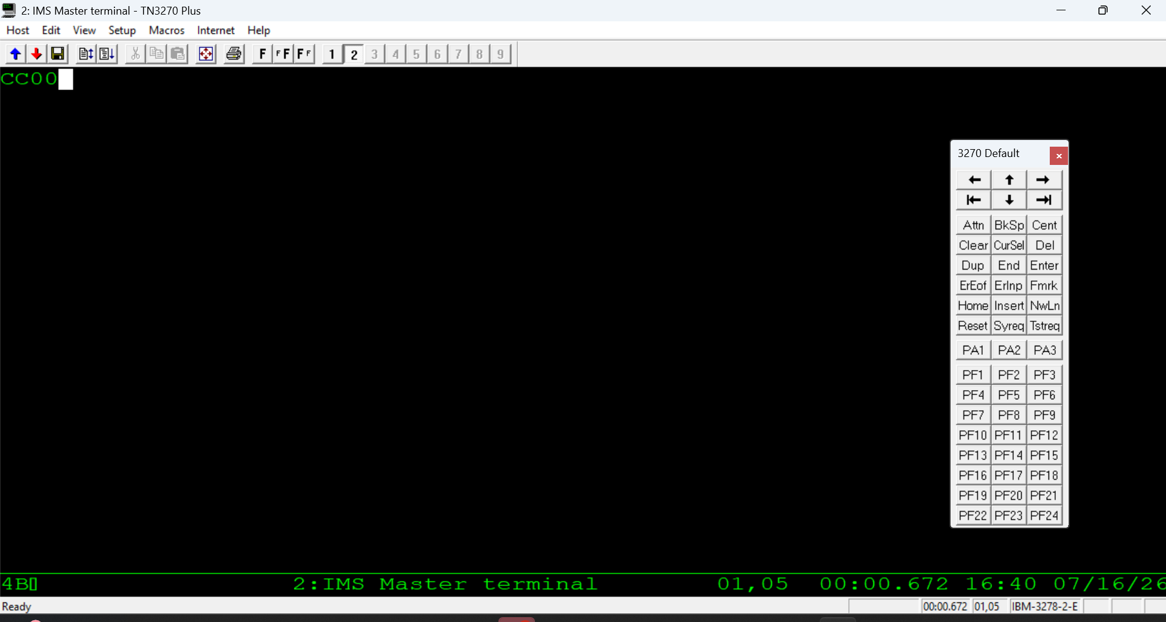

Figure 63: Entering transaction ID CC00.
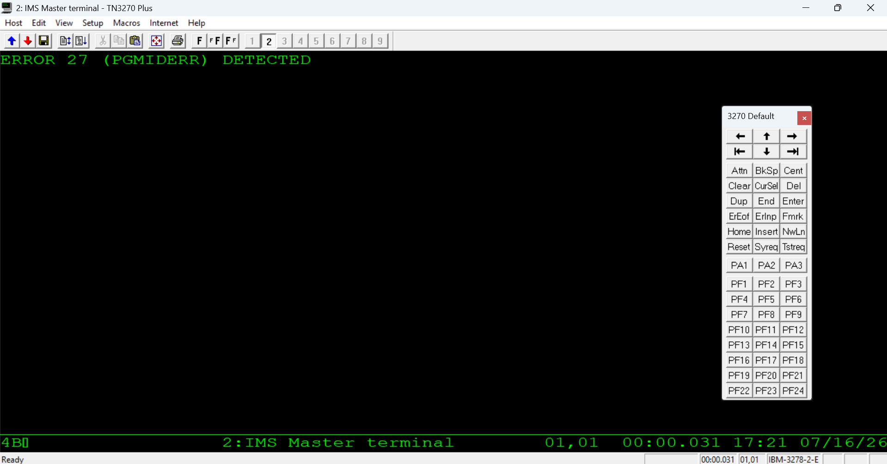

Figure 64: Error ID 27 returned after entering the transaction ID.
Known Issue: If this step errors out, check that the environment variable NIB_JAVA_DEMO_HOME is set correctly for the root project.

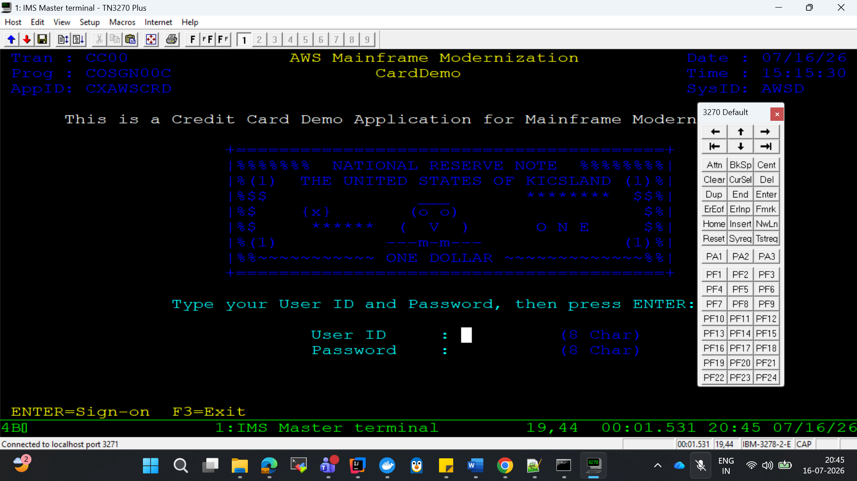

Figure 65: Login screen after entering transaction ID CC00.
Note: Supernaut container startup and request-handling logs captured from Docker at the time of this login are provided in the docker-supernaut-tn3270.log reference log.
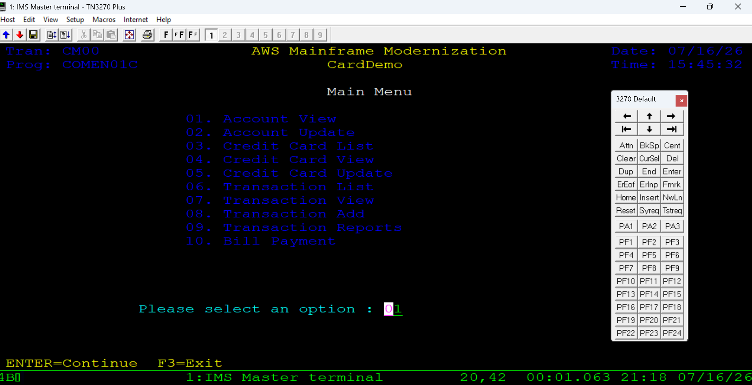

Figure 66: Main menu after login.
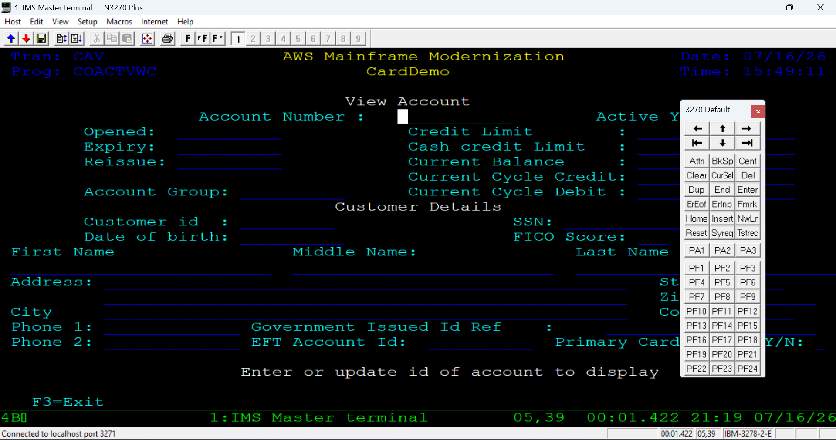

Figure 67: Account view menu.
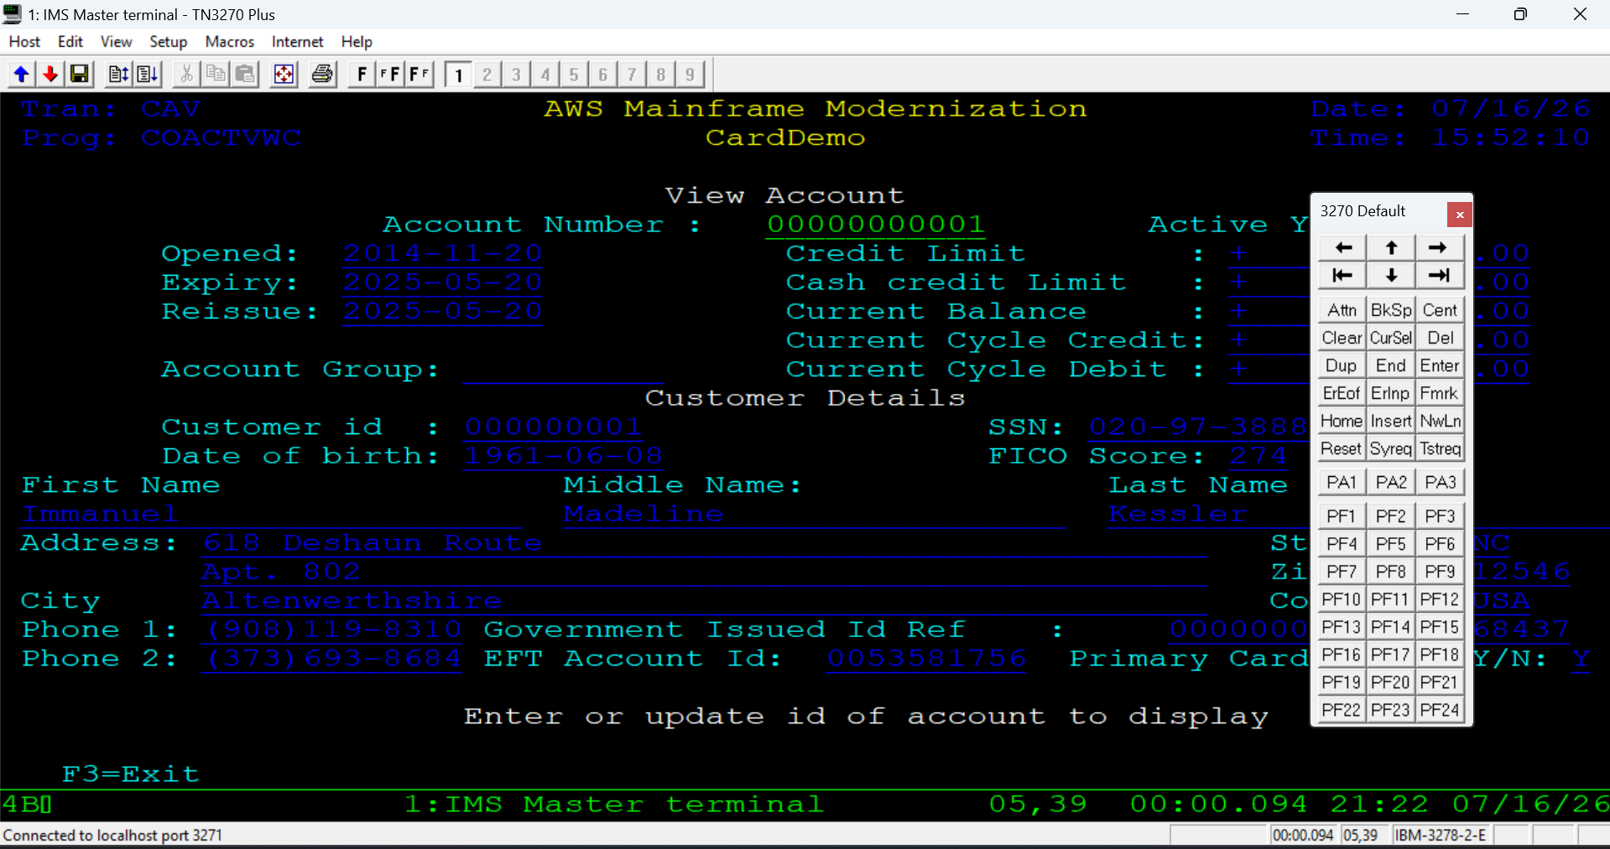

Figure 68: Account details displayed for the entered account number.

Method 2: Angular UI (Browser)
- In IntelliJ, run the boot-online application configuration using the required environment settings.
- Create a second application configuration named Boot Angular, with its Working Directory set to the Angular application folder.
- Run both boot-online and boot-angular to start the online application.
- Add the VM option -Duser.timezone=Asia/Kolkata to both the boot-online and boot-angular run configurations (this resolves an error that otherwise appears at startup — see below).
- Run both boot-online and boot-angular again.
- Open http://localhost:8088/nibservice/ in a browser.
- Log in with the same user and password used in the emulator.
- The same main menu seen in the emulator is displayed in the browser.
- Select a menu option — for example, option "01".
- Enter the 11-digit account number to view its details.
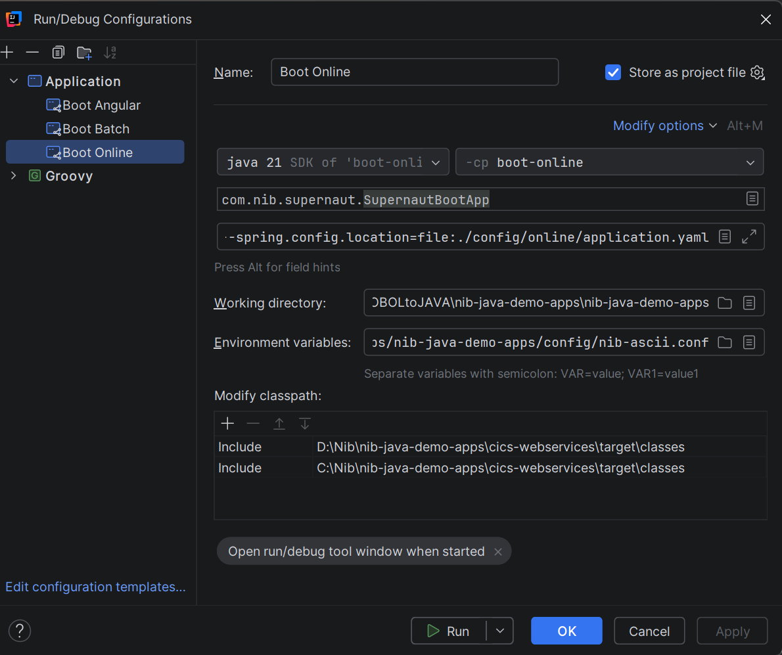

Figure 69: boot-online run configuration.
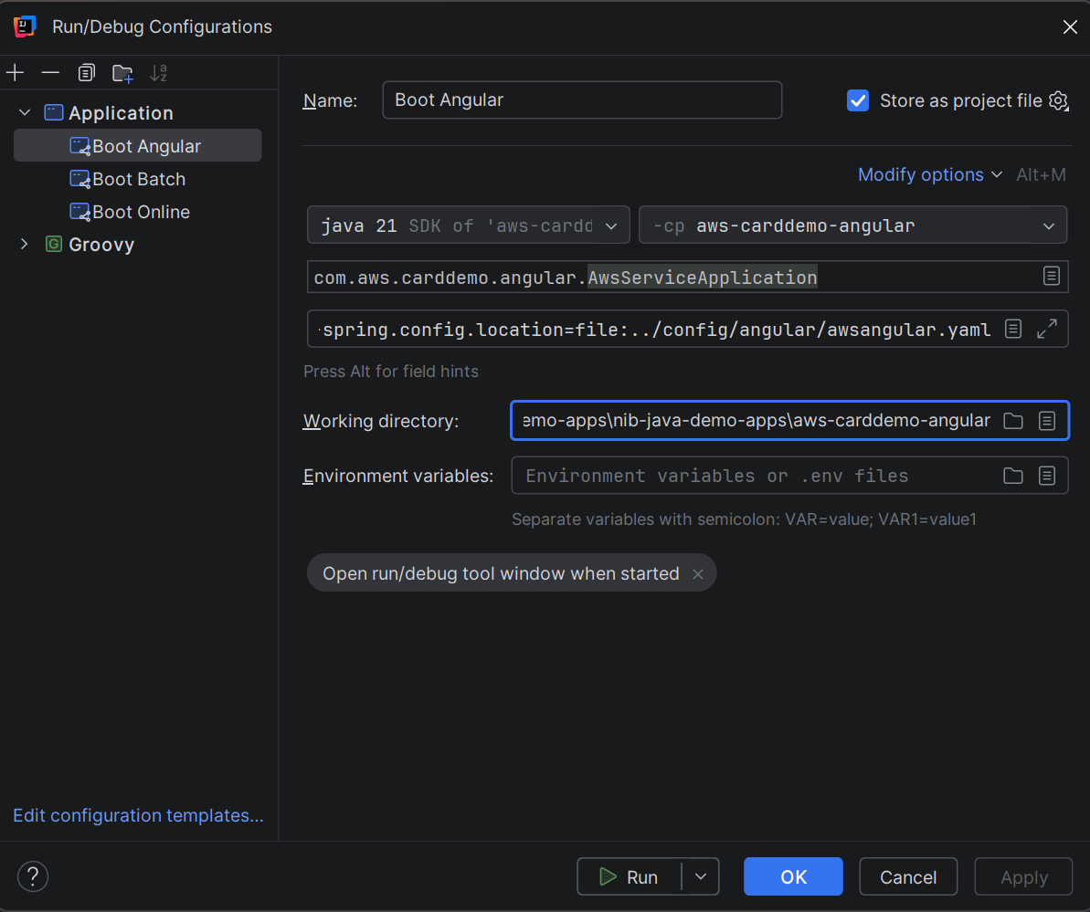

Figure 70: Boot Angular run configuration, with Working Directory set to the Angular application folder.
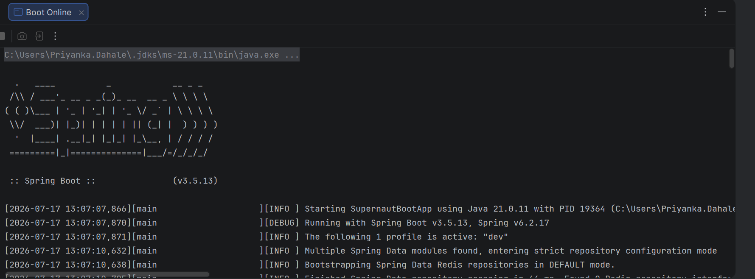

Figure 71: Console logs after starting both boot-online and boot-angular.
Note: An error can appear at this point, resolved by adding the VM option described in the next step.

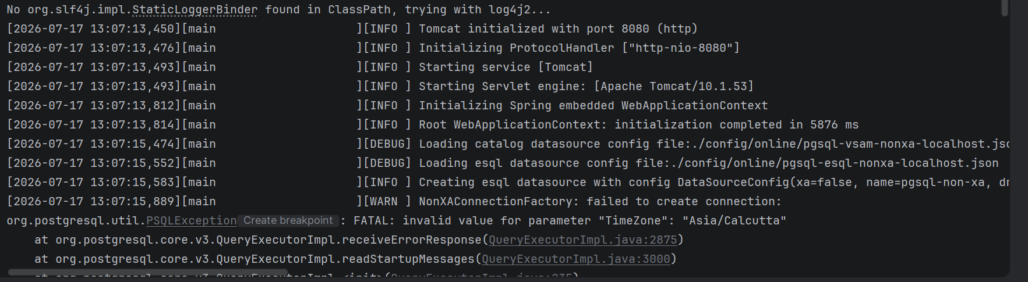

Figure 72: Error encountered after starting boot-online and boot-angular before the VM option fix is applied.
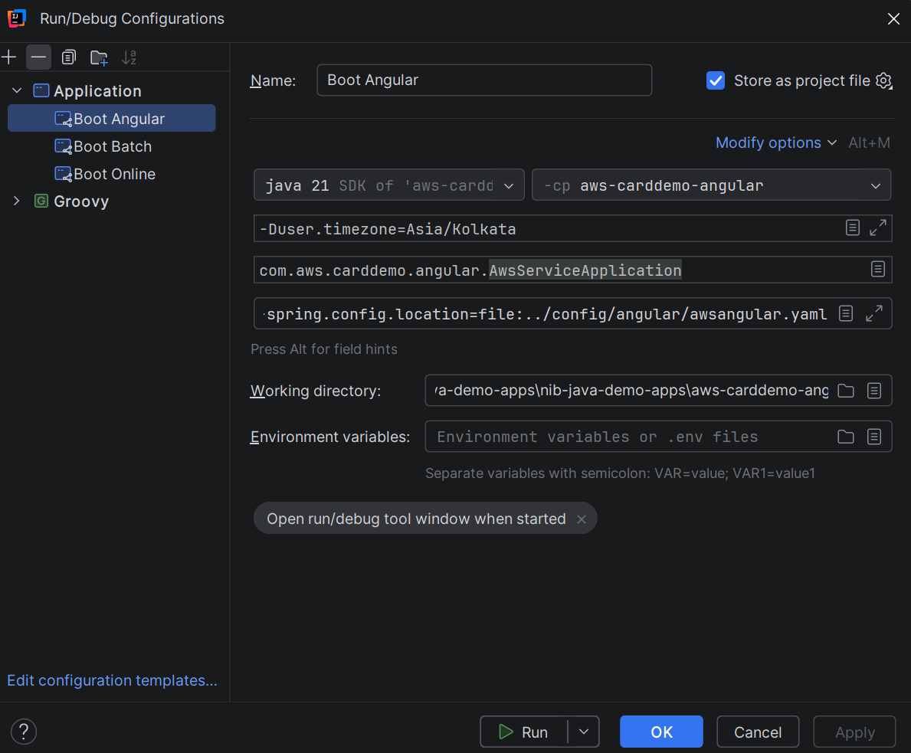

Figure 73: Adding the -Duser.timezone=Asia/Kolkata VM option to boot-angular.
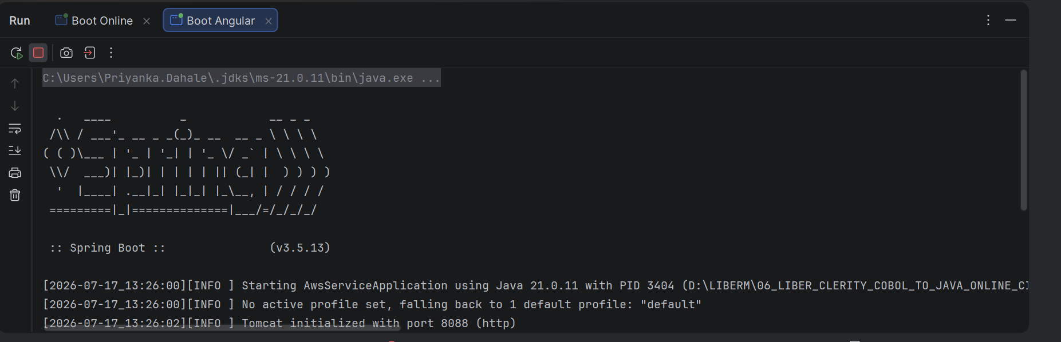

Figure 74: Both configurations running successfully after the VM option is applied.
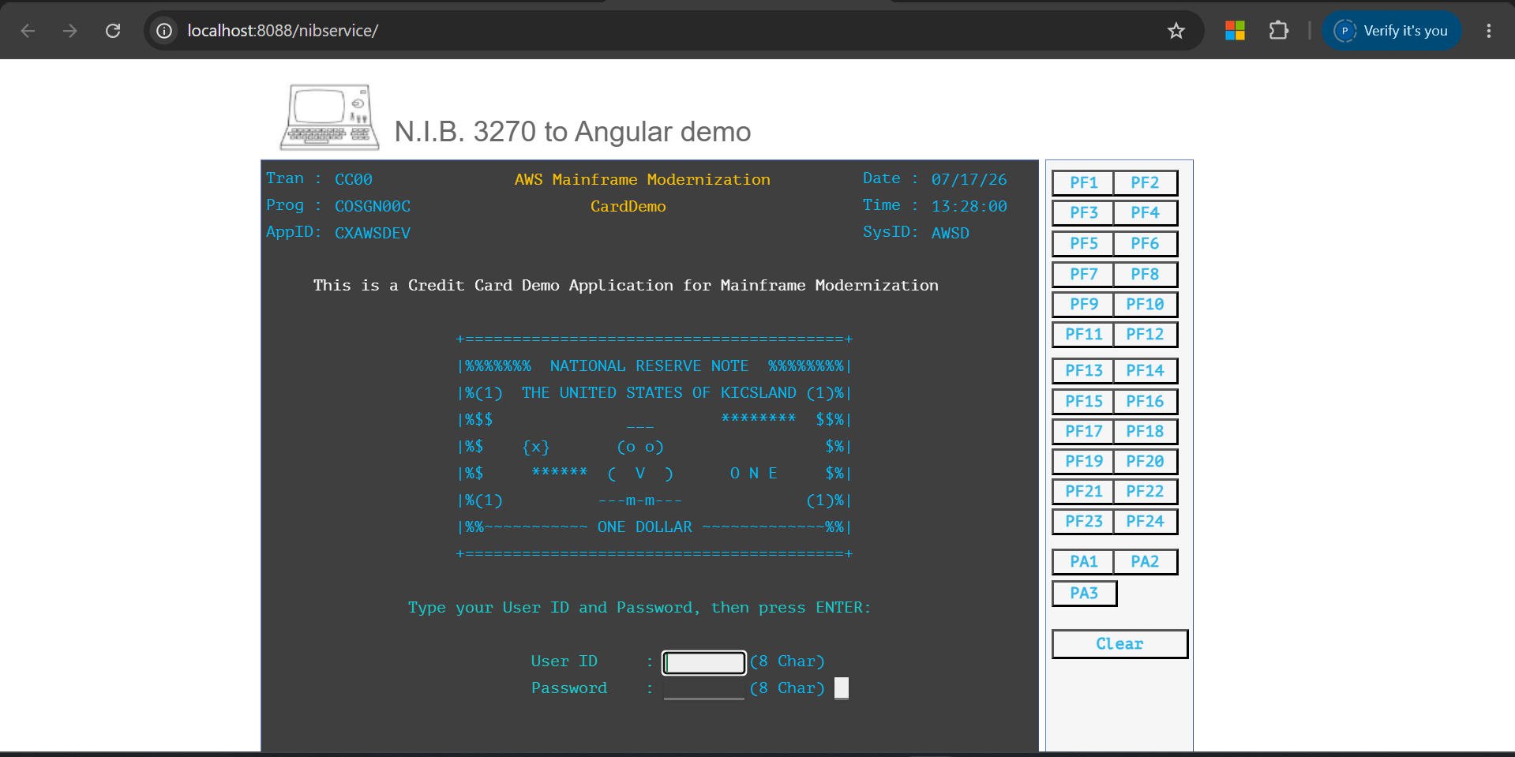

Figure 75: Application window opened in the browser.
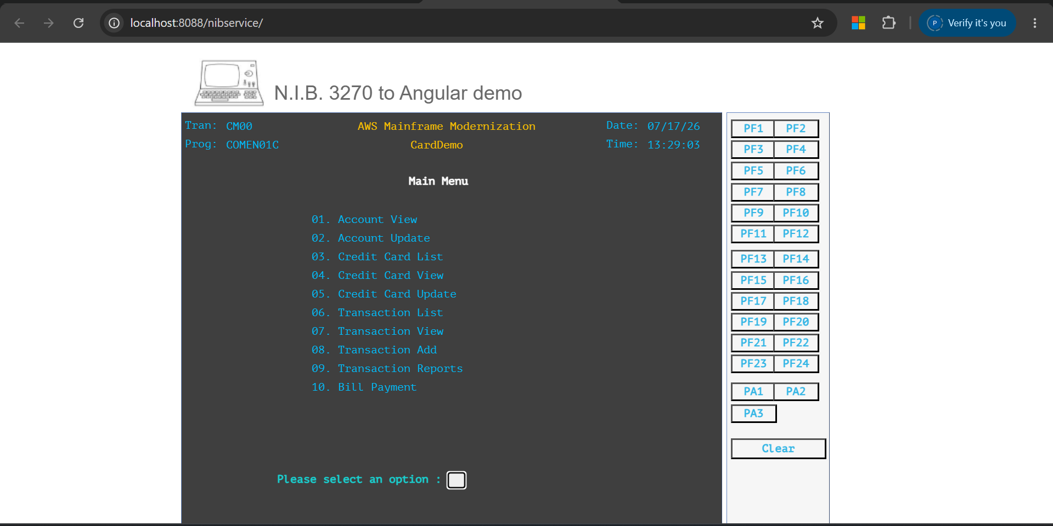

Figure 76: Main menu in the browser, matching the emulator menu.
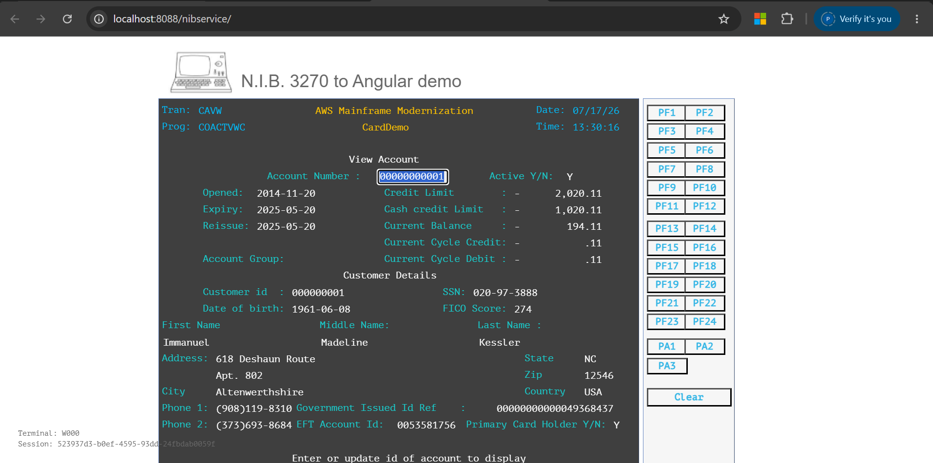

Figure 77: Account details window in the browser.

Testing Batch Jobs (boot-batch)
The LiberBatch framework provides REST APIs to invoke Groovy files. There are three ways to trigger a batch job: Postman, the Swagger UI, or PowerShell/CMD (cURL). The examples below use the Groovy script at aws-carddemo-app/src/groovy/custfile.groovy.

Submitting a Job via Postman
Endpoint:
POST http://localhost:8081/job/submit

Sample request body:
{
"script": "CUSTFILE.groovy",
"jobClass": "A",
"onHold": false,
"variables": {
"RUNDATE": "2026-07-17",
"PREFIX": "BTC001"
}
}

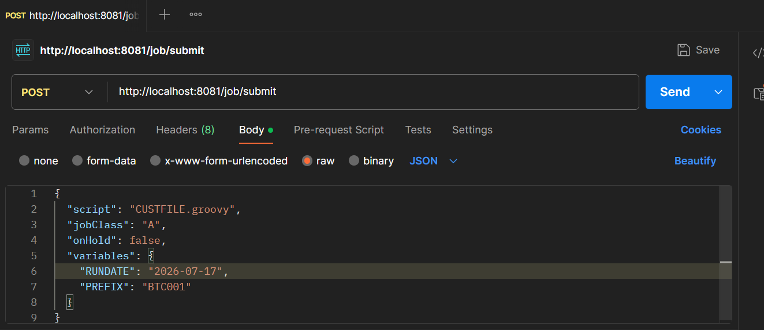

Figure 78: Submitting the job in Postman.
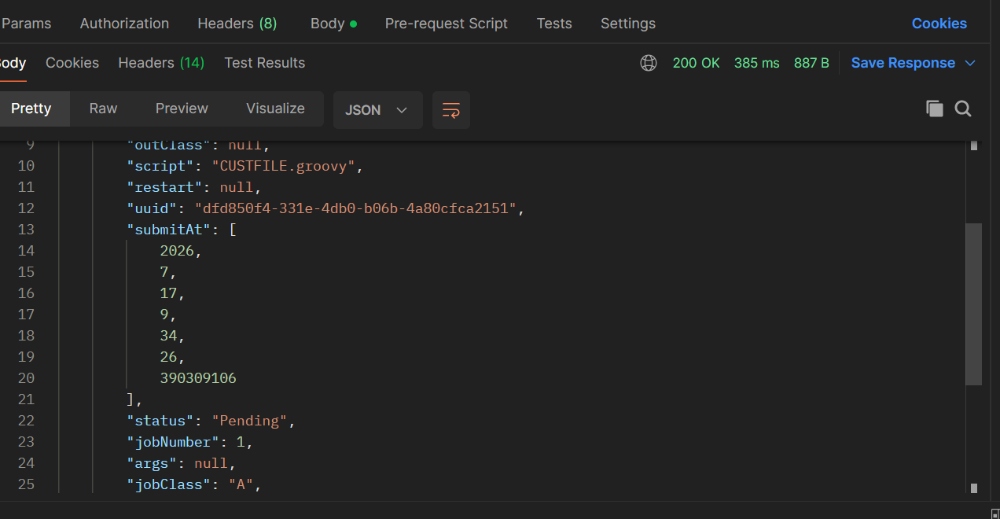

Figure 79: Response returned from the submit request.
The Docker logs for the Motorhead node (a-1 or a-2, matching the jobClass = A passed above) confirm the job was picked up:
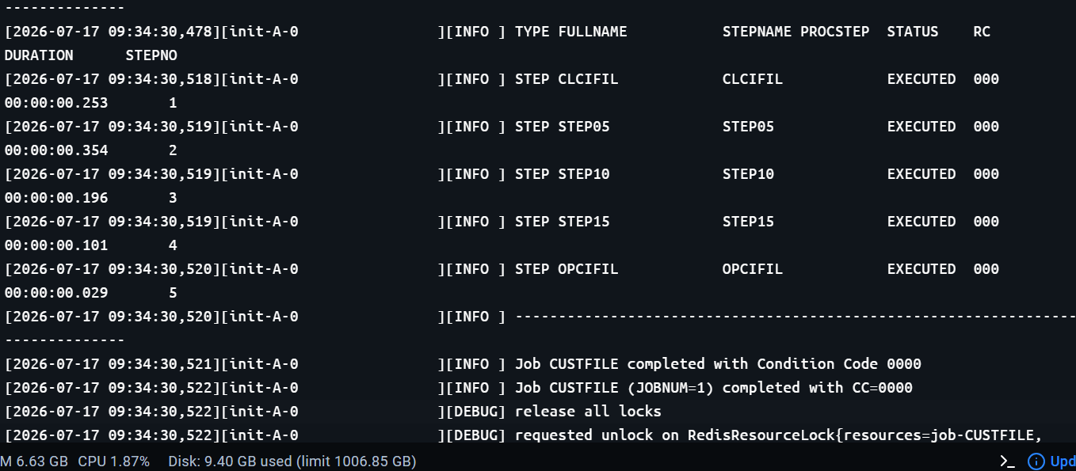

Figure 80: Docker logs for Motorhead node A picking up the submitted job.
Note: The full Motorhead / Spring Boot container startup and job-execution log for this batch run is provided in the docker-postman-batch.log reference log.

Checking Job Status
Copy the uuid returned in the submit response — this is the job ID, and is needed to monitor this specific job.
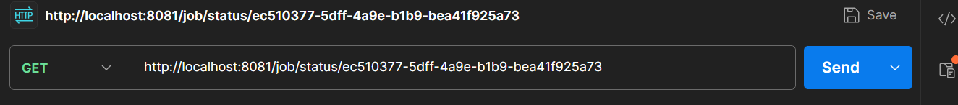

Figure 81: Checking job status using the copied uuid.
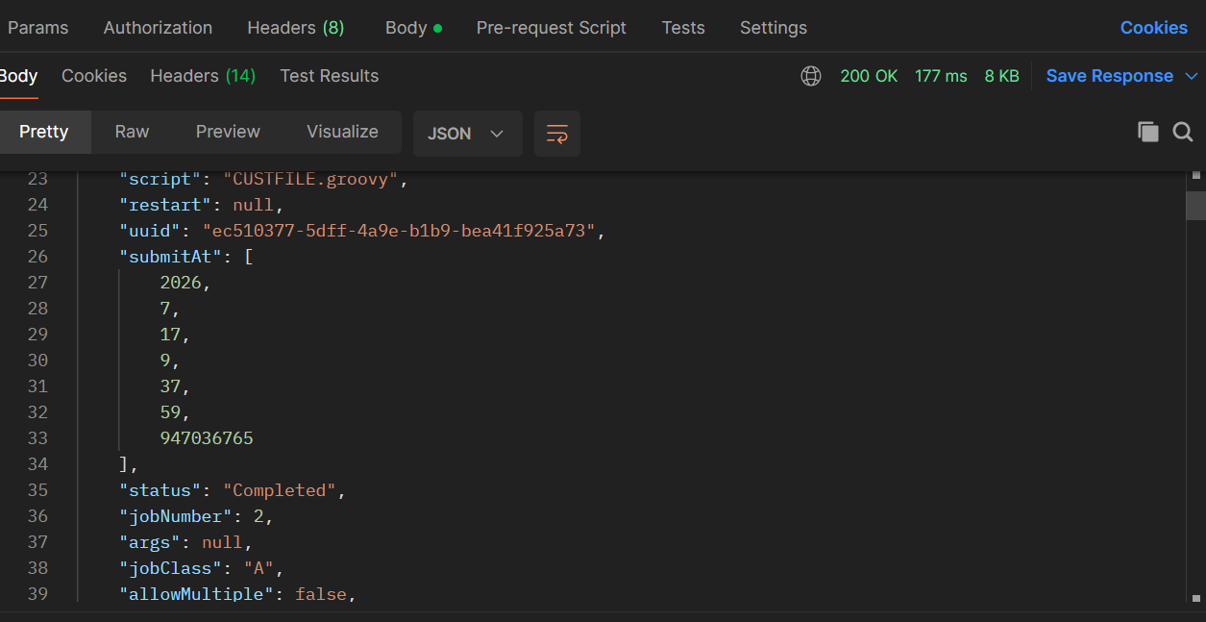

Figure 82: Job status response, showing per-step detail.
This response can be validated against the steps defined in custfile.groovy, since the step-level detail is included in the response.
Note: The full JSON response body for the job/status/{uuid} request, including per-step start/completion timestamps and status, is provided in the postman-job-status-uuid.log reference log.

Job List
The job/list endpoint also shows the step details and whether each job has executed or completed.
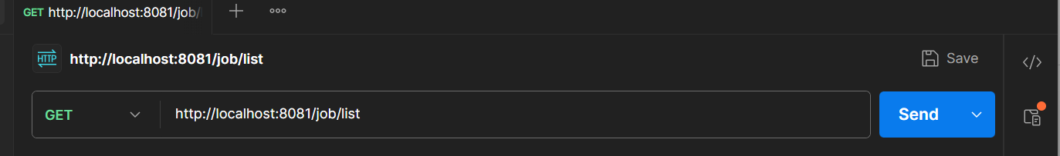

Figure 83: job/list response.

Verifying via Docker Logs
The Docker container logs also show whether each step executed and completed with return code 0.
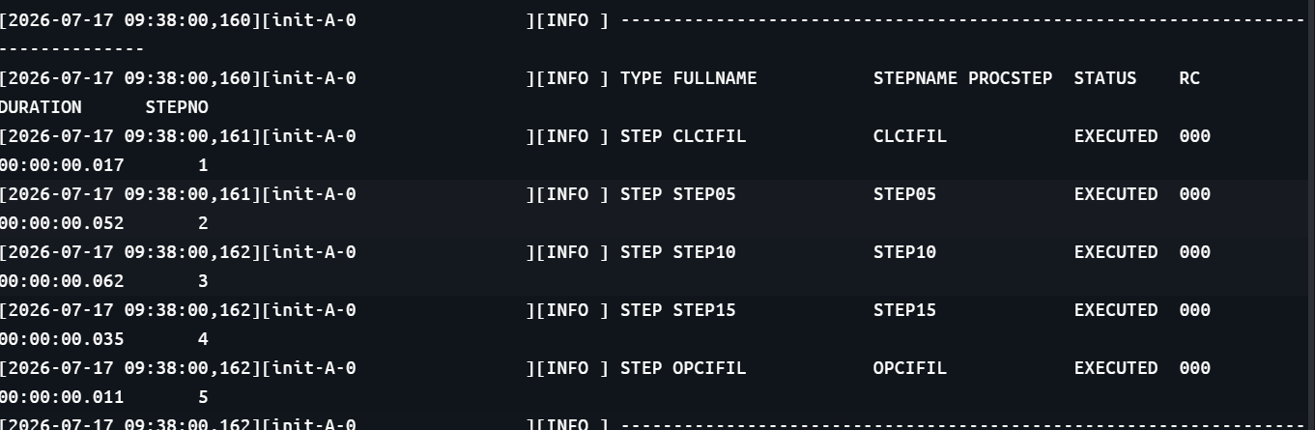

Figure 84: Docker logs showing per-step return codes.

Testing with Node Class B
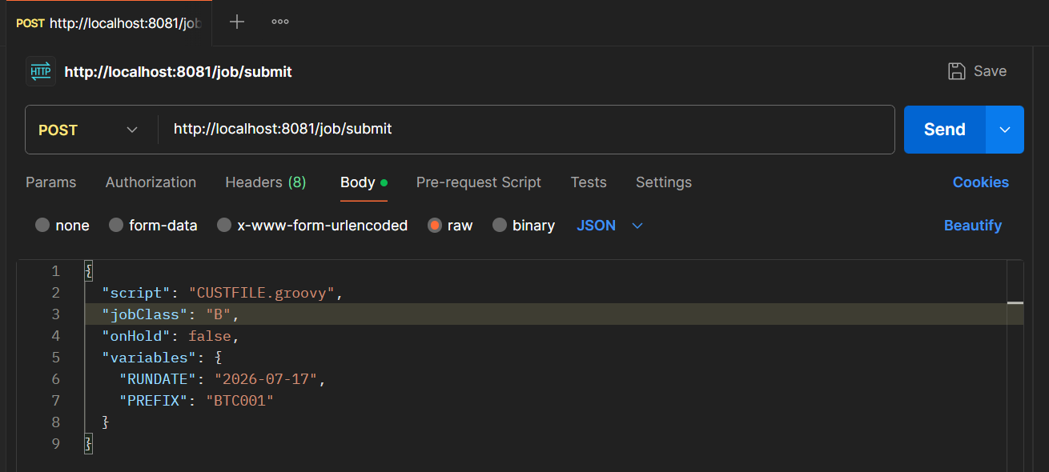

Figure 85: Submitting a job with node class B.
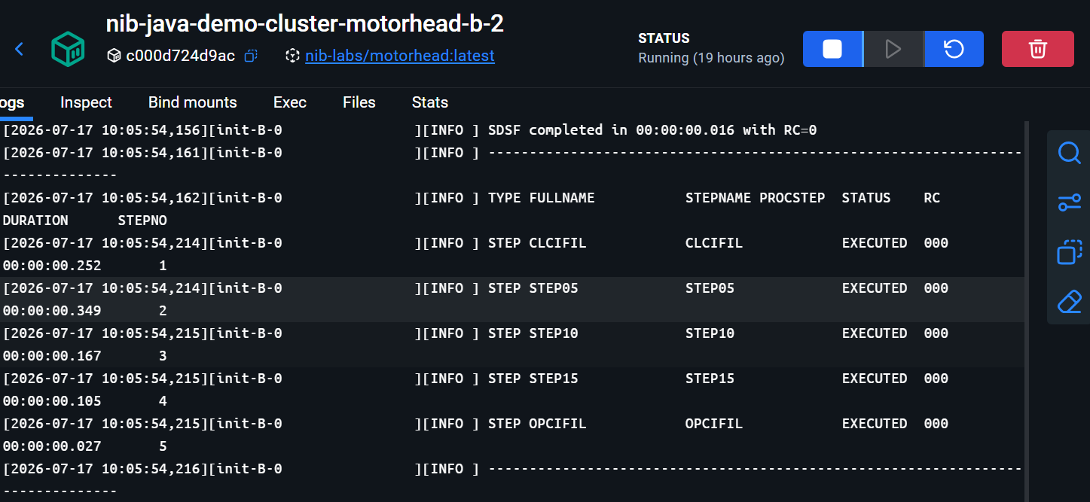

Figure 86: Docker logs for node class B.

Submitting via Swagger UI
The same job can be executed through the Swagger UI:
http://localhost:8081/swagger-ui/index.html

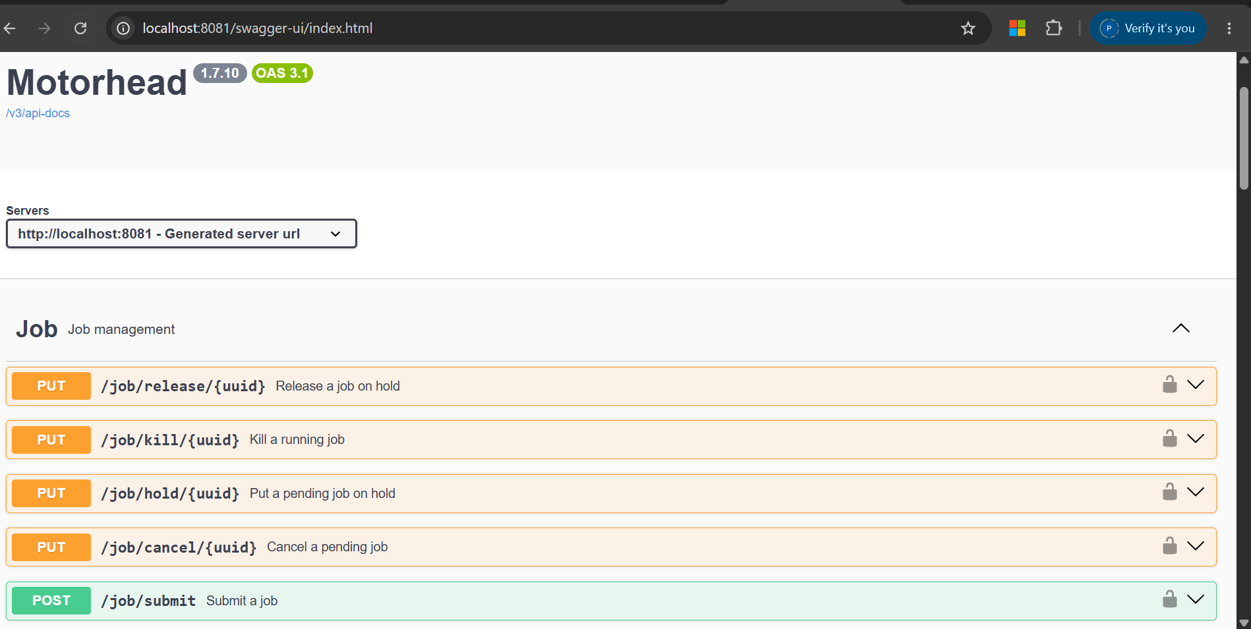

Figure 87: Swagger UI showing the available APIs.
Locate the submit-job API and execute it from Swagger.
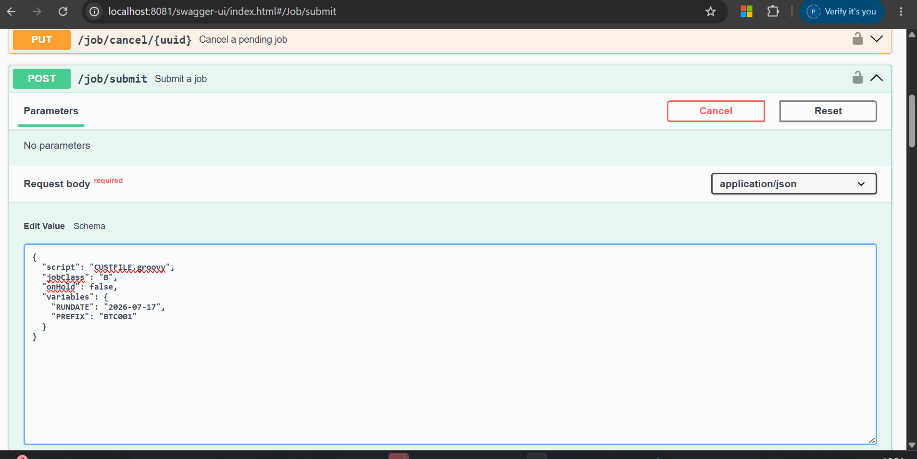

Figure 88: Executing the submit-job API from Swagger.
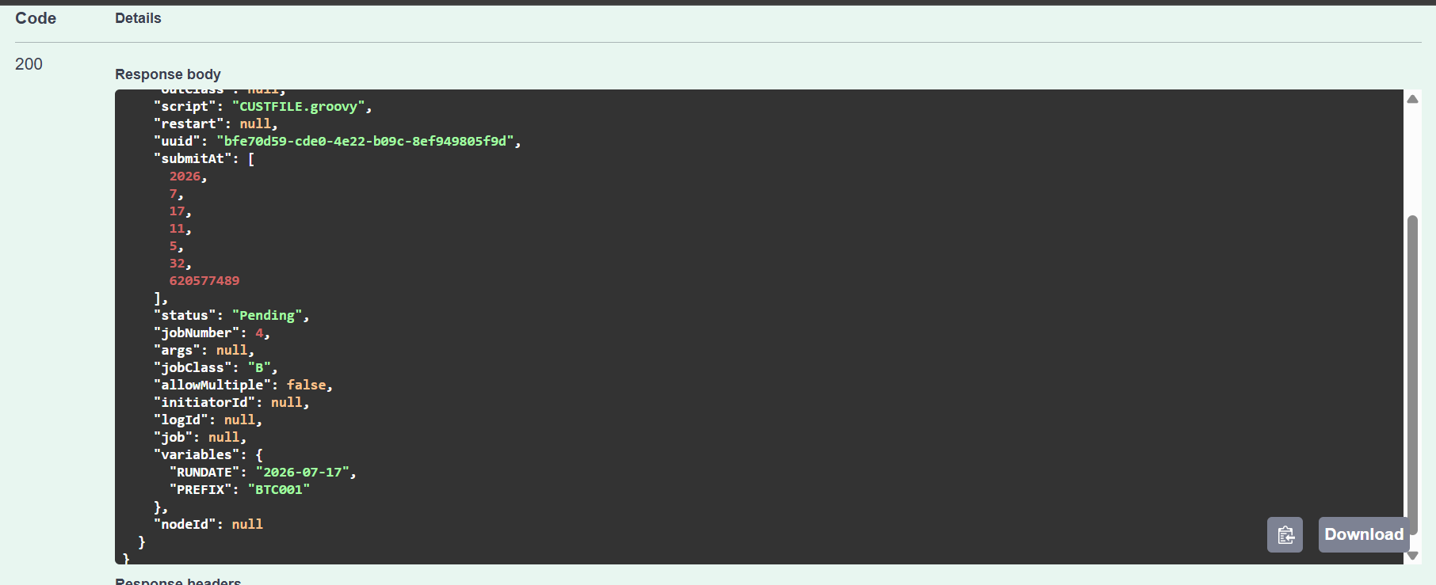

Figure 89: Response body for the job submitted via Swagger.

Local Debugging Setup
Important: Docker does not provide a facility to debug. To debug locally, stop all containers except rdbms and redis, and run the application itself (not the containerized version).
- Stop all Docker containers except rdbms and redis.
- Run the boot-online configuration in Debug mode, and run boot-angular normally.
boot-angular is the frontend: any transaction invoked from Angular first hits the frontend application, and control then passes to the Supernaut framework, which is the online region.
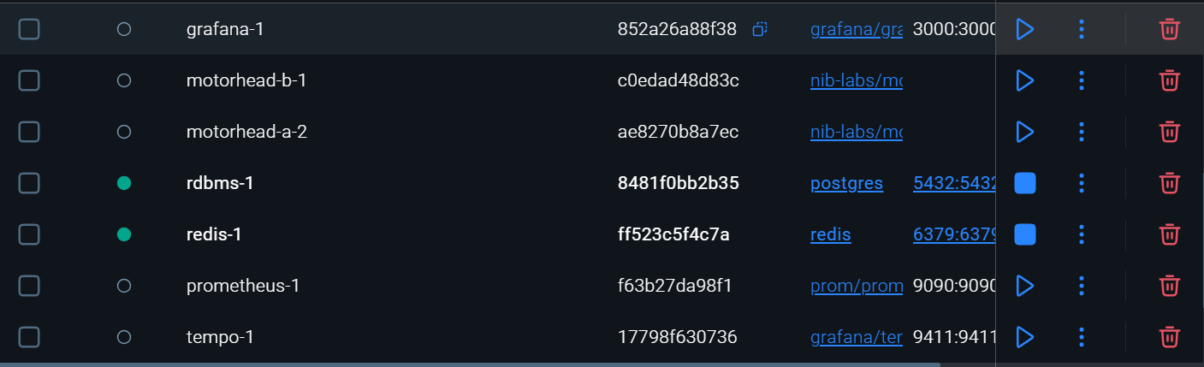

Figure 90: Docker containers with only rdbms and redis running.
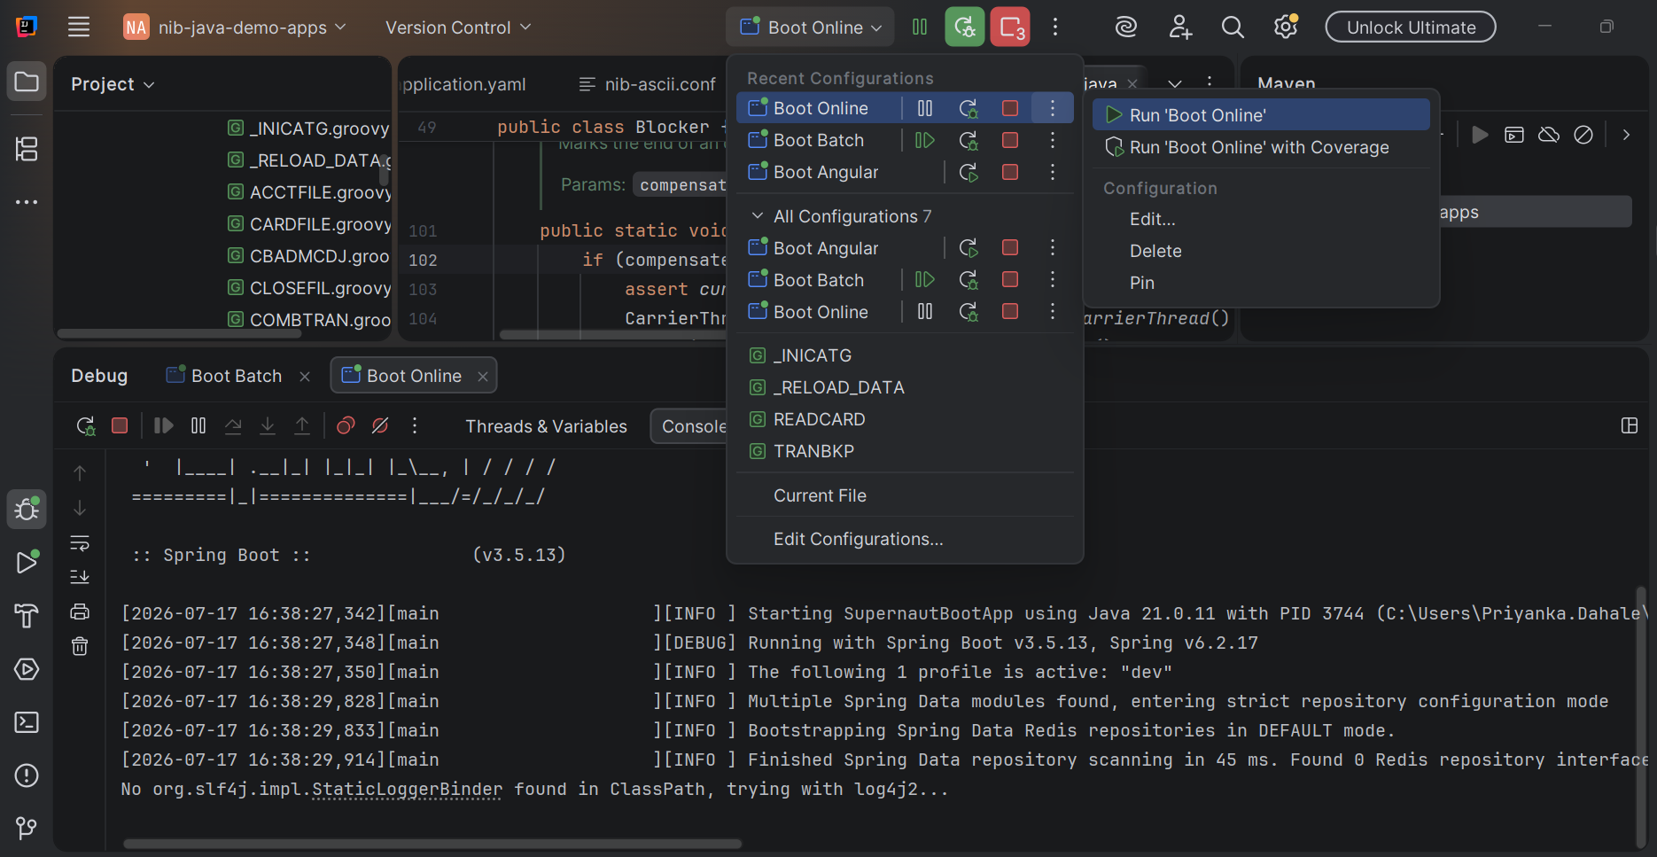

Figure 91: boot-online (debug) and boot-angular running.
Note: The IntelliJ debugger startup log for boot-online (debug mode) and boot-angular, including the full JVM launch command and classpath, is provided in the online-angular-debug.log reference log.

Transaction-to-Program Mapping (pct.json)
The transaction-to-program name mapping is defined in pct.json. In the mainframe, this mapping is handled through CICS and the PCT table; here it is represented in the pct.json configuration file. The group field in the JSON controls which users are authorized for a given transaction ID — a specific user ID can be used in place of a group.
- Set a breakpoint in the target program.
- Trigger the corresponding transaction from the Angular UI.
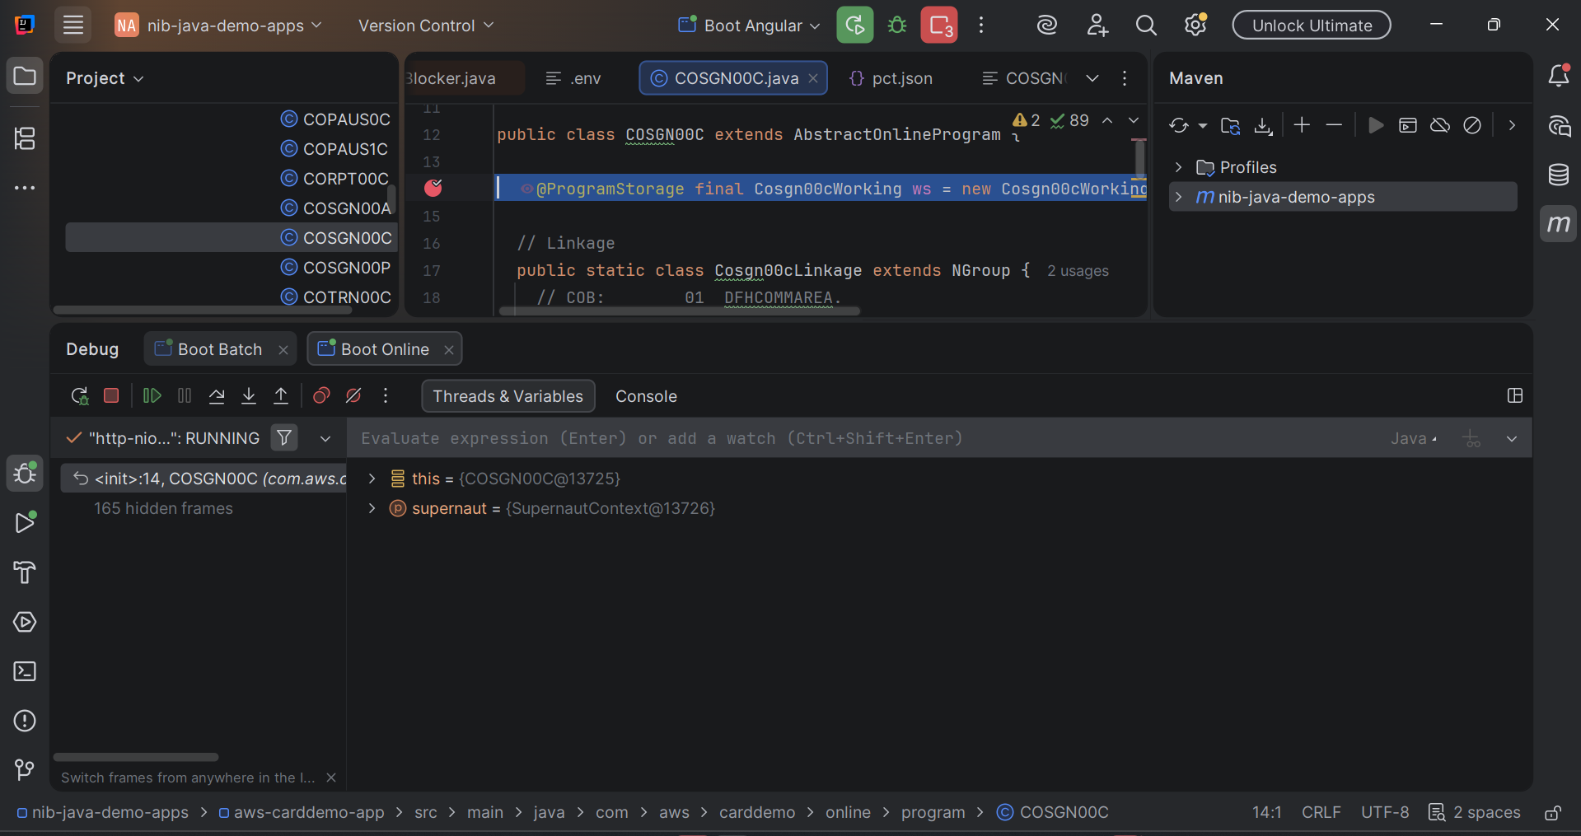

Figure 92: Breakpoint set in the target program.
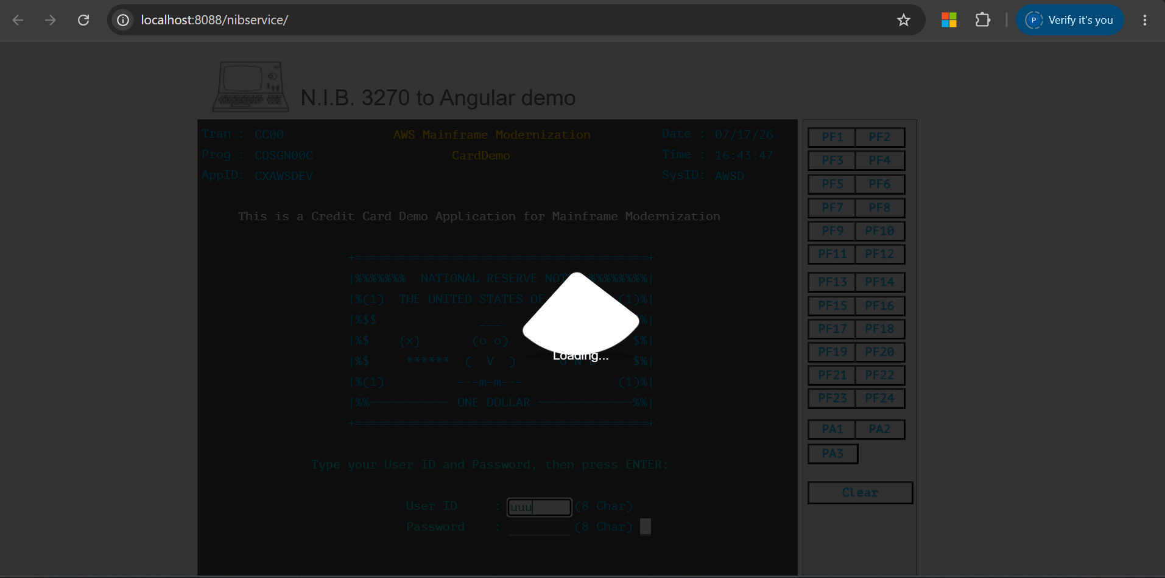

Figure 93: Breakpoint hit after triggering the transaction from the Angular UI.
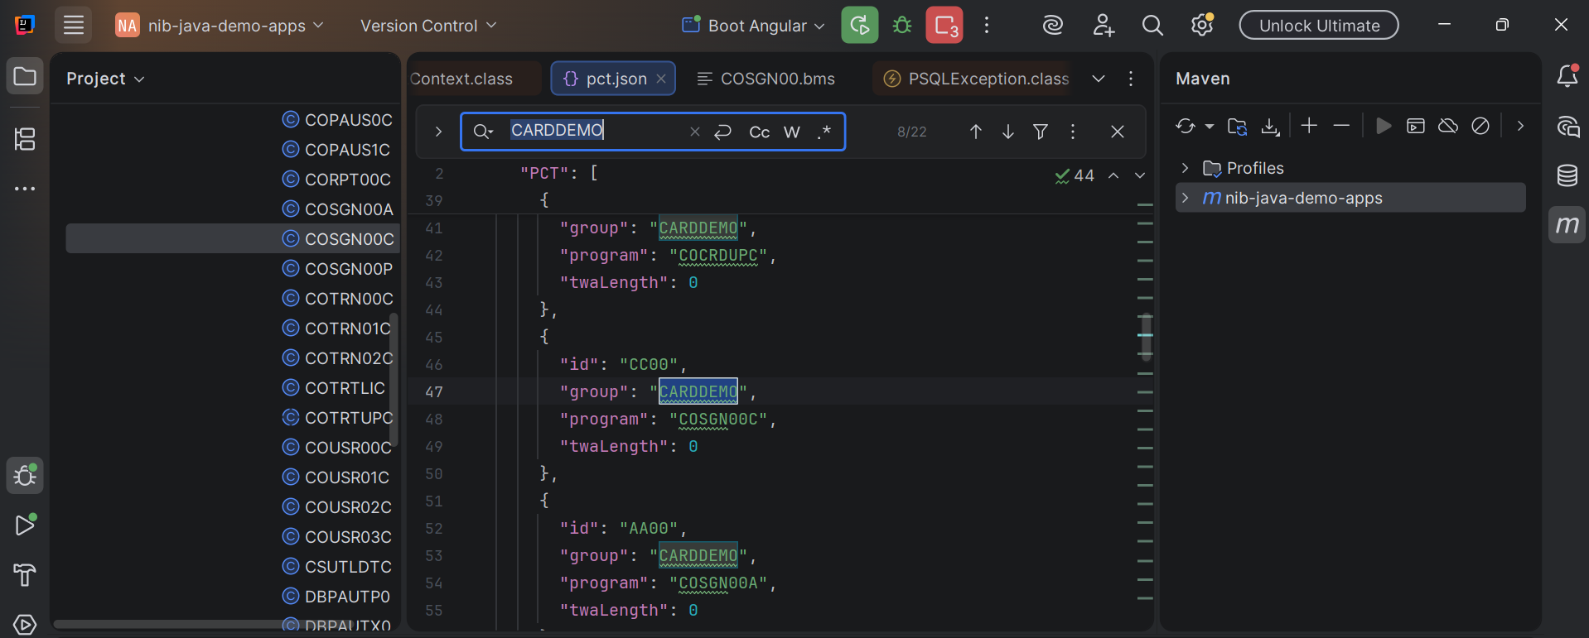

Figure 94: pct.json transaction-to-program mapping.

Troubleshooting
Issue | Resolution
Angular build fails; REST jar skipped | Install Node.js, then update the Angular animation packages and pin them in pom.xml as described in Resolving the Angular Build Failure.
docker compose up fails with "no configuration file provided" | Run the command from the deployment\docker-compose folder, not from the project root.
A container does not appear as running in Docker Desktop | Start the service manually from Docker Desktop.
Error at startup after running boot-online / boot-angular | Add the VM option -Duser.timezone=Asia/Kolkata to both run configurations.
Need to debug the online or Angular application | Stop all Docker containers except rdbms and redis, then run boot-online in Debug mode and boot-angular normally — Docker does not support debugging directly.

For guidance that applies to every conversion type in this guide, see Chapter 10, Common Troubleshooting.

CHAPTER 10

Common Troubleshooting
This chapter describes tools and techniques that apply across every conversion type covered in this guide: reviewing conversion logs, and using the Analyze.bat utility to generate a detailed error report. For issues specific to a single conversion, see the Troubleshooting section at the end of the relevant chapter.
System Error
In some environments, the conversion process may fail with a system-level error related to virtualization, CPU features, or security settings, as shown below.
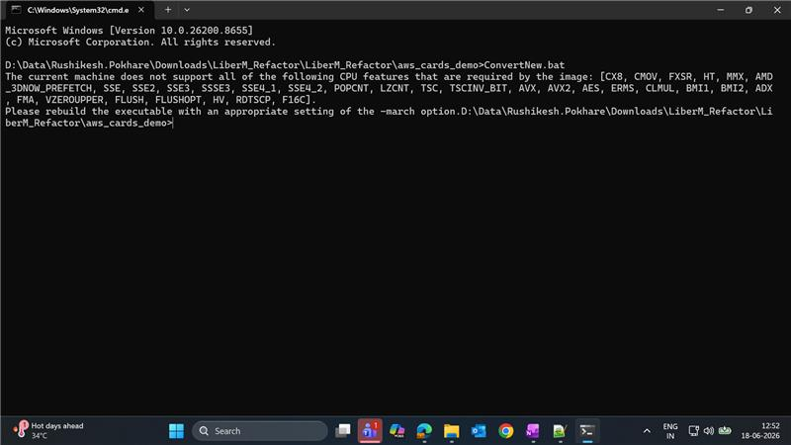

Figure 15: Example system-level error encountered during conversion, related to missing virtualization or CPU-feature support.

Identifying the Issue
- Open Command Prompt.
- Run the systeminfo command.
- Scroll through the output and locate the "Virtualization-based security: Status" line.
If the status is "Not Enabled", the issue is likely related to virtualization settings or a missing Windows feature.

Resolution Steps
- Verify that hardware virtualization is enabled in the system BIOS/UEFI settings.
- Enable the required Windows features (for example, Hyper-V and Virtual Machine Platform) through Windows Features or an equivalent system tool.
- Restart the machine and run the conversion command again.

Reviewing Conversion Logs
Every conversion writes log files to the logs folder inside the source package (for example, aws_cards_demo_v1.8.4\logs or aws_cards_demo\logs). These logs are the first place to check when a conversion produces no output, incomplete output, or unexpected results. They can help identify:
- Missing input files
- Incorrect or incomplete configuration
- Unsupported or invalid input objects
- Conversion errors
- License-related errors
- Runtime or executable version issues

Using Analyze.bat
Every conversion package includes a helper script named Analyze.bat, located in the source folder alongside Convert.bat / ConvertNew.bat. Analyze.bat reads the available conversion logs automatically and produces an Excel report listing the identified errors, which is much easier to review than reading the raw log files directly.
- Open the package's source folder (for example, aws_cards_demo or aws_cards_demo_v1.8.4).
- Run Analyze.bat by double-clicking it, or by executing it from Command Prompt.
- Analyze.bat reads all available logs and generates an Excel report — for example, AnalysisReport_22-06-2026_09-33-27.71.xlsx — in the package folder.
- Open the report in Microsoft Excel and review the listed errors.

Resolving Common Analyze.bat Issues

Executable Name Mismatch
If Analyze.bat fails to run correctly, open it in Notepad and verify that the nib-paranoid executable name referenced by the script matches the actual .exe file present in the package folder. For example, if Analyze.bat references nib-paranoid-1.7.12.exe but the actual executable available is nib-paranoid-1.7.22.exe, update the script to use the correct executable name, save the file, and run Analyze.bat again.
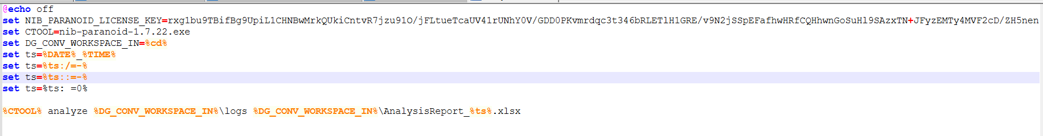
NIB License Error
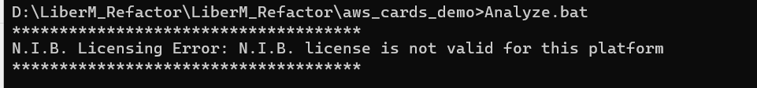
Figure 50: Example NIB license error reported by Analyze.bat.
If Analyze.bat (or Convert.bat / ConvertNew.bat) reports a message such as "N.I.B. Licensing Error: N.I.B. license is not valid for this platform":
- Ensure the NIB license key is the same in both the conversion script (Convert.bat / ConvertNew.bat) and Analyze.bat.
- Confirm that the license key is valid and has not expired.
- Re-run the script from Command Prompt after correcting the license configuration.

General Troubleshooting Checklist
Symptom | Where to Look
No output generated | Source path, active configuration file, and the delivery_project_root / output variable used by that configuration.
Conversion fails partway through | logs folder for the package, then re-run Analyze.bat for a consolidated report.
License error | The license key value in both the conversion script and Analyze.bat.
Output written to the wrong location | The location and output attributes in the active XML configuration file, and the DG_CONV_WORKSPACE_IN / DG_CONV_WORKSPACE_OUT variables.
Analyze.bat will not run | The nib-paranoid executable name referenced inside Analyze.bat versus the actual .exe file present in the package.

Note: Keep the original mainframe source files (COBOL, JCL, PROC, or BMS) unchanged throughout the conversion process, so that the generated output can always be compared against the original source behavior.

APPENDIX A

Configuration Quick Reference
The table below summarizes the configuration file, source pattern, source location, and output location used by each conversion described in this guide.
Conversion | Configuration File | Pattern | Source Location | Output Location
COBOL Batch → C# | conv_cobol_batch_c#_config.xml | CB*, DSN*, CS* | sources\cbl | ${delivery_project_root}
COBOL Online → C# | conv_cobol_online_c#_config.xml | CO* | sources\cbl | ${delivery_project_root}
JCL → Groovy | conv_jcl_groovy_config.xml | * (or a specific file name) | sources\jcl | ${delivery_project_root}
JCL → PowerShell | conv_jcl_pwsh_config.xml | * | sources\jcl | ${delivery_project_root}\...\Scripts
PROCLIB → PowerShell | conv_proc_pwsh_config.xml | * or TR* | sources\proc | ${delivery_project_root}\...\Scripts\Procs
PROCLIB → Groovy | conv_proc_groovy_config.xml | * or TR* | sources\proc | ${delivery_project_root}\src\main\groovy\procs
BMS → JSON/HTML/TS | conv_bms_angular_config.xml | * | sources\bms | ${delivery_project_root}\src\main\resources
CICS COBOL Online → Java | conv_cobol_online_java_config.xml | CO* | sources\cbl | ${delivery_project_root}\...\online\program
COBOL Batch → Java | conv_cobol_batch_java_config.xml | CB*, DSN*, CS* | sources\cbl | nib-java-demo-apps (Maven project)
PROC → Groovy (batch framework) | conv_proc_groovy_config.xml | * or TR* | sources\proc | aws-carddemo-app/src/groovy

For the meaning of each attribute (pattern, location, output) and the general workflow used to run any of these conversions, see Chapter 2, Getting Started.

